1. Chuẩn bị môi trường

Step 1/ thay đổi file /etc/hosts trên 2 server st-vlt-db1/st-vlt-db2

User root

#Ipublic

10.10.10.209 st-vlt-db1.viettel.vietlott.vn st-vlt-db1

10.10.10.210 st-vlt-db2.viettel.vietlott.vn st-vlt-db2

#Private

192.168.14.209 st-vlt-db1-priv.viettel.vietlott.vn st-vlt-db1-priv

192.168.14.210 st-vlt-db2-priv.viettel.vietlott.vn st-vlt-db2-priv

#Vip-Ip

10.10.10.211 st-vlt-db1-vip.viettel.vietlott.vn st-vlt-db1-vip

10.10.10.212 st-vlt-db2-vip.viettel.vietlott.vn st-vlt-db2-vip

#SCAN-Ip

10.10.10.213 st-vlt-db-scan.viettel.vietlott.vn st-vlt-db-scan

10.10.10.214 st-vlt-db-scan.viettel.vietlott.vn st-vlt-db-scan

10.10.10.215 st-vlt-db-scan.viettel.vietlott.vn st-vlt-db-scan

Step 2/ cấu hình IP tren ethernet adapter thu 2 tren 2 server st-vlt-db1/st-vlt-db2

User root

systemctl stop NetworkManager.service

systemctl disable NetworkManager.service

ip link set virbr0 down

brctl delbr virbr0

systemctl stop avahi-daemon  
systemctl disable avahi-daemon

cd /etc/sysconfig/network-*/

DEVICE=ens224

TYPE=Ethernet

BOOTPROTO=none

NM_CONTROLLED=yes

DEFROUTE=yes

IPV4_FAILURE_FATAL=yes

IPV6INIT=no

NAME="ens224"

ONBOOT=yes

IPADDR=192.168.14.209

NETMASK=255.255.255.0

Step 3/ Setting dns (neu chua cau hinh) tren 2 node

vi /etc/resolv.conf

domain viettel.vietlott.vn

options attempts:2 timeout:1

nameserver 10.10.6.26

nameserver 10.10.6.27

service network restart

---OEL6 (CHANGE HOSTNAME)

# vi /etc/sysconfig/network

# reboot

Step 4: Mount disk and package

mkdir –p /repos/rhel/7

mount -o loop /dev/sr0 /repos/rhel/7

##OR

mount /dev/cdrom /repos/rhel/7

vi /etc/yum.repos.d/rhel7.repo

[InstallMedia]

name=Oracle Linux 7.3

mediaid=1438065927.78

metadata_expire=-1

gpgcheck=1

cost=500

enabled=1

baseurl=file:///mnt/

gpgkey=file:///etc/pki/rpm-gpg/RPM-GPG-KEY-oracle

:wq!

yum clean metadata

yum clean all

yum repolist

Step 5: Install package ORACLE

# All of the above

yum install binutils* -y

yum install compat* -y

yum install gcc* -y

yum install glibc* -y

yum install ksh* -y

yum install libgcc* -y

yum install libstdc* -y

yum install libaio* -y

yum install libXext* -y

yum install libXtst* -y

yum install libX11 -y

yum install libXau* -y

yum install libxcb* -y

yum install libXi* -y

yum install make* -y

yum install sysstat* -y

yum install coreutils* -y

yum install elfutils* -y

yum install unixODBC* -y

yum install sysstat* -y

yum install xorg-x11* -y

yum install nfs-utils.x86_64

yum install smartmontools.x86_64

yum install libXxf86dga* -y

====Move below files to folder /repos/rhel/oracle

# cd /repos/rhel/oracle

# ls |grep oracle

kmod-oracleasm-2.0.8-22.el7.x86_64.rpm

oracleasmlib-2.0.12-1.el7.x86_64.rpm

kmod-oracleasm-2.0.8-22.1.el7_6.x86_64.rpm

oracleasm-support-2.1.11-2.el7.x86_64.rpm

oracle-database-server-12cR2-preinstall-1.0-2.el6.x86_64.rpm

oracle-database-server-12cR2-preinstall-1.0-3.el6.x86_64.rpm

oracle-database-server-12cR2-preinstall-1.0-4.el6.x86_64.rpm

oracle-database-server-12cR2-preinstall-1.0-5.el6.x86_64.rpm

compat-libstdc++-33-3.2.3-72.el7.x86_64.rpm#

yum search createrepo

yum install createrepo.noarch

createrepo --database /repos/rhel/oracle

yum install local oracleasm*

yum install local oracle-database-server-12cR2-preinstall*

Step 6: Configuration ORACLE

---Stop iptables on both nodes

systemctl stop firewalld

---start NTP

/sbin/service ntpd start

/sbin/service ntpd status

OR

systemctl stop ntpd.service

systemctl status chronyd.service

systemctl disable chronyd.service

----ADD sysctl.conf

cat >> /etc/sysctl.conf <<EOF

fs.file-max = 6815744

kernel.sem = 250 32000 100 128

kernel.shmmni = 4096

kernel.shmmax = 4398046511104

kernel.panic_on_oops = 1

net.core.rmem_default = 262144

net.core.rmem_max = 4194304

net.core.wmem_default = 262144

net.core.wmem_max = 1048576

fs.aio-max-nr = 1048576

net.ipv4.ip_local_port_range = 9000 65500

EOF

---- ADD limits.conf

cat >> /etc/security/limits.conf <<EOF

grid soft nproc 2047

grid hard nproc 16384

grid soft nofile 1024

grid hard nofile 65536

oracle soft nproc 2047

oracle hard nproc 16384

oracle soft nofile 1024

oracle hard nofile 65536

* soft memlock 3145728

* hard memlock 3145728

#Oracle recommended value for stack is set to 10240 for user grid and oracle

grid soft stack 10240

oracle soft stack 10240

EOF

---- ADD /etc/sysconfig/ntpd on both nodes

vi /etc/sysconfig/ntpd

# Command line options for ntpd

OPTIONS="-x -g"

---- Add login root

cat >> /etc/pam.d/login <<EOF

session required pam_limits.so

EOF

---- /etc/selinux/config

vi /etc/selinux/config

# This file controls the state of SELinux on the system.

# SELINUX= can take one of these three values:

# enforcing - SELinux security policy is enforced.

# permissive - SELinux prints warnings instead of enforcing.

# disabled - No SELinux policy is loaded.

SELINUX=disabled

# SELINUXTYPE= can take one of these two values:

# targeted - Targeted processes are protected,

# mls - Multi Level Security protection.

SELINUXTYPE=targeted

Step 7: Create OS groups using the commands below:

Enter commands as the root user:

groupadd -g 1003 oinstall

groupadd -g 1005 dba

groupadd -g 1004 oper

groupadd -g 1000 asmadmin

groupadd -g 1001 asmdba

groupadd -g 1002 asmoper

useradd -u 1001 -g oinstall -G dba,asmdba,asmadmin,asmoper -d /home/grid -m grid

useradd -u 1000 -g oinstall -G dba,oper,asmdba,asmoper,asmadmin -d /home/oracle -m oracle

chown -R grid:oinstall grid

chown -R oracle:oinstall oracle

Step 8: Set the password for the oracle account using the following command.

Enter commands as the root user:

[root@st-vlt-db2 home]# passwd grid

Changing password for user grid.

New password:

BAD PASSWORD: The password contains the user name in some form

Retype new password:

passwd: all authentication tokens updated successfully.

[root@st-vlt-db2 home]# passwd oracle

Changing password for user oracle.

New password:

BAD PASSWORD: The password contains the user name in some form

Retype new password:

passwd: all authentication tokens updated successfully.

###user root

# id oracle

uid=54321(oracle) gid=54321(oinstall) groups=54321(oinstall),54322(dba),54324(asmdba),54326(oper)

# id oracle

uid=54321(oracle) gid=54321(oinstall) groups=54321(oinstall),54322(dba),54324(asmdba),54326(oper)

# id grid

uid=54322(grid) gid=54321(oinstall) groups=54321(oinstall),54323(asmadmin),54324(asmdba),54325(asmoper)

# id grid

uid=54322(grid) gid=54321(oinstall) groups=54321(oinstall),54323(asmadmin),54324(asmdba),54325(asmoper)

Step 9: Configuration .bash_profile user grid node 1

------------------------------------------------------------------------------------

############################NODE1###################################################

su - grid

vi .bash_profile

# .bash_profile

# Get the aliases and functions

if [ -f ~/.bashrc ]; then

. ~/.bashrc

fi

# User specific environment and startup programs

PATH=$PATH:$HOME/.local/bin:$HOME/bin

export PATH

#Grid Environment node1

export DISPLAY=localhost:10.0

ORACLE_SID=+ASM1; export ORACLE_SID

JAVA_HOME=/bin/java; export JAVA_HOME

ORACLE_BASE=/app/grid; export ORACLE_BASE

ORACLE_HOME=/app/12c/grid; export ORACLE_HOME

ORACLE_TERM=xterm; export ORACLE_TERM

TNS_ADMIN=$ORACLE_HOME/network/admin; export TNS_ADMIN

PATH=.:${JAVA_HOME}/bin:${PATH}:$HOME/bin:$ORACLE_HOME/bin

PATH=${PATH}:/usr/bin:/bin:/usr/local/bin

export PATH

export TEMP=/tmp

export TMPDIR=/tmp

umask 022

#source .bash_profile

Step 10: Configuration .bash_profile user grid node 2

############################NODE2###################################################

su - grid

vi .bash_profile

# .bash_profile

# Get the aliases and functions

if [ -f ~/.bashrc ]; then

. ~/.bashrc

fi

# User specific environment and startup programs

PATH=$PATH:$HOME/.local/bin:$HOME/bin

export PATH

#Grid Environment node2

export DISPLAY=localhost:10.0

ORACLE_SID=+ASM2; export ORACLE_SID

JAVA_HOME=/bin/java; export JAVA_HOME

ORACLE_BASE=/app/grid; export ORACLE_BASE

ORACLE_HOME=/app/12c/grid; export ORACLE_HOME

ORACLE_TERM=xterm; export ORACLE_TERM

TNS_ADMIN=$ORACLE_HOME/network/admin; export TNS_ADMIN

PATH=.:${JAVA_HOME}/bin:${PATH}:$HOME/bin:$ORACLE_HOME/bin

PATH=${PATH}:/usr/bin:/bin:/usr/local/bin

export PATH

export TEMP=/tmp

export TMPDIR=/tmp

umask 022

#source .bash_profile

###testing on both nodes under user grid

echo $ORACLE_SID

Step 11: Configuration .bash_profile user oracle node 1

------------------------------------------------------------------------------------

############################NODE1###################################################

su - oracle

vi .bash_profile

# .bash_profile

# Get the aliases and functions

if [ -f ~/.bashrc ]; then

. ~/.bashrc

fi

# User specific environment and startup programs

PATH=$PATH:$HOME/.local/bin:$HOME/bin

export PATH

# Oracle environment node 1

export DISPLAY=localhost:10.0

ORACLE_BASE=/app/oracle; export ORACLE_BASE

ORACLE_HOME=$ORACLE_BASE/product/12c/vietlott_db; export ORACLE_HOME

ORACLE_TERM=xterm; export ORACLE_TERM

export JAVA_HOME=/usr/bin/java

PATH=/usr/sbin:/usr/bin:$PATH; export PATH

PATH=$ORACLE_HOME/bin:$ORACLE_HOME/perl/bin:$ORACLE_HOME/OPatch:$PATH;export PATH

LD_LIBRARY_PATH=$ORACLE_HOME/lib:/lib:/usr/lib; export LD_LIBRARY_PATH

CLASSPATH=$ORACLE_HOME/JRE:$ORACLE_HOME/jlib:$ORACLE_HOME/rdbms/jlib;

export CLASSPATH

ORACLE_SID=vietlottb1; export ORACLE_SID

EDITOR=vi; export EDITOR

umask 022

#source .bash_profile

Step 12: Configuration .bash_profile user oracle node 2

############################NODE2###################################################

su - oracle

# .bash_profile

# Get the aliases and functions

if [ -f ~/.bashrc ]; then

. ~/.bashrc

fi

# User specific environment and startup programs

PATH=$PATH:$HOME/.local/bin:$HOME/bin

export PATH

# Oracle environment node 2

export DISPLAY=localhost:10.0

ORACLE_BASE=/app/oracle; export ORACLE_BASE

ORACLE_HOME=$ORACLE_BASE/product/12c/vietlott_db; export ORACLE_HOME

ORACLE_TERM=xterm; export ORACLE_TERM

export JAVA_HOME=/usr/bin/java

PATH=/usr/sbin:/usr/bin:$PATH; export PATH

PATH=$ORACLE_HOME/bin:$ORACLE_HOME/perl/bin:$ORACLE_HOME/OPatch:$PATH;export PATH

LD_LIBRARY_PATH=$ORACLE_HOME/lib:/lib:/usr/lib; export LD_LIBRARY_PATH

CLASSPATH=$ORACLE_HOME/JRE:$ORACLE_HOME/jlib:$ORACLE_HOME/rdbms/jlib;

export CLASSPATH

ORACLE_SID=vietlottb2; export ORACLE_SID

EDITOR=vi; export EDITOR

umask 022

#########################################################################################################

#source .bash_profile

step10: reboot 2 nodes

su - root

init 0

step 13: create partitions on node 1 under user root

# One Node

---fdisk /dev/sdc5

# fdisk /dev/sdc5

Device contains neither a valid DOS partition table, nor Sun, SGI or OSF disklabel

Building a new DOS disklabel with disk identifier 0x1013c33c.

Changes will remain in memory only, until you decide to write them.

After that, of course, the previous content won't be recoverable.

Warning: invalid flag 0x0000 of partition table 4 will be corrected by w(rite)

WARNING: DOS-compatible mode is deprecated. It's strongly recommended to

switch off the mode (command 'c') and change display units to

sectors (command 'u').

Command (m for help): n

Command action

e extended

p primary partition (1-4)

p

Partition number (1-4): 1

First cylinder (1-1304, default 1):

Using default value 1

Last cylinder, +cylinders or +size{K,M,G} (1-1304, default 1304):

Using default value 1304

Command (m for help): w

The partition table has been altered!

Calling ioctl() to re-read partition table.

WARNING: Re-reading the partition table failed with error 22: Invalid argument.

The kernel still uses the old table. The new table will be used at

the next reboot or after you run partprobe(8) or kpartx(8)

Syncing disks.

#Do the same steps for the remaining disks

fdisk /dev/sdc5

fdisk /dev/sdc6

fdisk /dev/sdc7

fdisk /dev/sdc8

fdisk /dev/sdc9

fdisk /dev/sdc10

fdisk /dev/sdc11

fdisk /dev/sdd1

fdisk /dev/sde1

# Do on the 2 nodes under user root

su - root

# /usr/sbin/oracleasm configure -i

Configuring the Oracle ASM library driver.

This will configure the on-boot properties of the Oracle ASM library

driver. The following questions will determine whether the driver is

loaded on boot and what permissions it will have. The current values

will be shown in brackets ('[]'). Hitting <ENTER> without typing an

answer will keep that current value. Ctrl-C will abort.

Default user to own the driver interface []: grid

Default group to own the driver interface []: asmdba

Start Oracle ASM library driver on boot (y/n) [n]: y

Scan for Oracle ASM disks on boot (y/n) [y]: y

Writing Oracle ASM library driver configuration: done

---This can be verified using

# /usr/sbin/oracleasm configure

ORACLEASM_ENABLED=true

ORACLEASM_UID=grid

ORACLEASM_GID=asmdba

ORACLEASM_SCANBOOT=true

ORACLEASM_SCANORDER=""

ORACLEASM_SCANEXCLUDE=""

ORACLEASM_USE_LOGICAL_BLOCK_SIZE="false"

#

---Initialize the asmlib with the oracleasm init command to load oracleasm module and mount the oracleasm filesystem:

---on both nodes with user root

# /usr/sbin/oracleasm init

# /usr/sbin/oracleasm init

Creating /dev/oracleasm mount point: /dev/oracleasm

Loading module "oracleasm": oracleasm

Configuring "oracleasm" to use device physical block size

Mounting ASMlib driver filesystem: /dev/oracleasm

#

--- Node 1 with root

oracleasm scandisks

oracleasm listdisks

--- Node 2 with root

# oracleasm scandisks

# oracleasm listdisks

-- Node 1 only

#User root

/usr/sbin/oracleasm createdisk OCR1 /dev/sdb1

/usr/sbin/oracleasm createdisk REDO /dev/sdb2

/usr/sbin/oracleasm createdisk OCR2 /dev/sdc1

/usr/sbin/oracleasm createdisk BKP1 /dev/sdc2

/usr/sbin/oracleasm createdisk OCR3 /dev/sdd1

/usr/sbin/oracleasm createdisk BKP2 /dev/sdd2

/usr/sbin/oracleasm createdisk IDX /dev/sde1

/usr/sbin/oracleasm createdisk ARC /dev/sdf1

/usr/sbin/oracleasm createdisk DATA /dev/sdg1

/usr/sbin/oracleasm createdisk LOG /dev/sdh1

##veriy

[root@st-vlt-db2 7]# oracleasm listdisks

ARC

BKP1

BKP2

DATA

IDX

LOG

OCR1

OCR2

OCR3

REDO

Step 14 Creating the Oracle RDBMS Home Directory

--- Check the SCAN address is still being resolved properly on both nodes.

ping -c 4 st-vlt-db1

ping -c 4 st-vlt-db2

ping -c 4 st-vlt-db1-priv

ping -c 4 st-vlt-db2-priv

---Create folders on both node under user root

#mkdir -p /app/oraInventory/

#chown -R grid:oinstall /app/oraInventory/

#chmod -R 755 /app/oraInventory/

#mkdir -p /app/grid

#chown -R grid:oinstall /app/grid

#chmod -R 755 /app/grid

#mkdir -p /app/oracle

#chown -R oracle:oinstall /app/oracle

#chmod -R 755 /app/oracle

#mkdir -p /app/12c/grid

#chown -R grid:oinstall /app/12c/

#chmod -R 755 /app/12c

#chown -R grid:oinstall /app/12c/grid

#chmod -R 755 /app/12c/grid

#mkdir -p /app/oracle/product/12c/vietlott_db

#chown -R oracle:oinstall /app/oracle/product/12c/vietlott_db

#chmod -R 755 /app/oracle/product/12c/vietlott_db

----copy setup files to below folders, and do the 12.1.0.2 setup, do on the node 1 only

#cd /app/12c/grid

# unzip V840012-01.zip

# unzip p6880880_122010_Linux-x86-64.zip

Type A, then Enter

--- Check for correct Opatch.

# cd /app/12c/grid/OPatch/

#./opatch version

OPatch Version: 12.2.0.1.21

OPatch succeeded.

mkdir -p /app/12c/grid/patch

#cd /app/12c/grid/patch

# unzip p30920127_122010_Linux-x86-64.zip

#chown -R grid:oinstall /app/12c

#chmod -R 755 /app/12c

cd /app/setup/oracle

# unzip V839960-01.zip

# chown -R oracle:oinstall /app/setup/oracle

# chmod -R 775 /app/setup/oracle

step 15: Configure SSH Setup 12C Make sshsetup on both nodes (No password)

--No pass oracle

cd /app/12c/grid/oui/prov/resources/scripts

./sshUserSetup.sh -user oracle -hosts "st-vlt-db1 st-vlt-db2" -noPromptPassphrase -confirm -advanced

oracle@123

---No pass Grid

./sshUserSetup.sh -user grid -hosts "st-vlt-db1 st-vlt-db2" -noPromptPassphrase -confirm -advanced

grid@123

---No pass root

./sshUserSetup.sh -user root -hosts "st-vlt-db1 st-vlt-db2" -noPromptPassphrase -confirm -advanced

VDI@2020

---testing

user root: ssh st-vlt-db1/st-vlt-db1 sucessfully without password needed

user grid: ssh st-vlt-db1/st-vlt-db1 sucessfully without password needed

user oracle: ssh st-vlt-db1/st-vlt-db1 sucessfully without password needed

Step 16: ---Install the package cvudisk from the grid home as the “root” user on all nodes.

---1st Node

user root

# cd /app/12c/grid/cv/rpm

# rpm -Uvh cvuqdisk*

Preparing… ################################# [100%]

Using default group oinstall to install package

Updating / installing…

1:cvuqdisk-1.0.10-1 ################################# [100%]

---scp to 2nd Node

scp ./cvuqdisk* root@st-vlt-db2:/tmp

scp /usr/sbin/smartctl root@st-vlt-db2:/usr/sbin

ssh root@st-vlt-db2 rpm -Uvh /tmp/cvuqdisk*

--on 1st node

cd /app/12c/grid/cv/admin

# vi cvu_config

# Fallback to this distribution id

CV_ASSUME_DISTID=OEL4 --- OEL7

---- on 1st node, verify configurations:

su - grid

cd /app/12c/grid

./runcluvfy.sh comp nodereach -n "st-vlt-db1,st-vlt-db2" -verbose

./runcluvfy.sh stage -pre crsinst -n st-vlt-db1,st-vlt-db2 -verbose

###Install vnc server

[root@dbr1 ~]# su - oracle

[oracle@dbr1 ~]$ vncserver

You will require a password to access your desktops.

Password:

Verify:

xauth: file /home/oracle/.Xauthority does not exist

New 'dbr1:1 (oracle)' desktop is dbr1:1

Creating default startNextNext

up script /home/oracle/.vnc/xstartup

Starting applications specified in /home/oracle/.vnc/xstartup

Log file is /home/oracle/.vnc/dbr1:1.log

[oracle@dbr1 ~]$

[oracle@dbr1 ~]$ su - grid

Password:

[grid@dbr1 ~]$ vncserver

You will require a password to access your desktops.

Password:

Verify:

xauth: file /home/grid/.Xauthority does not exist

New 'dbr1:2 (grid)' desktop is dbr1:2

Creating default startup script /home/grid/.vnc/xstartup

Starting applications specified in /home/grid/.vnc/xstartup

Log file is /home/grid/.vnc/dbr1:2.log

123456a@

########Alert Log File: /u01/app/oracle/diag/rdbms/dbr/dbr1/trace/alert_dbr1.log

<https://mathijsbruggink.com/category/clsrsc-400/>

---- on 1st node, apply patch and starting Grid Infrastructure:

su – grid

Open VNC Viewer:

cd /app/12c/grid

./gridSetup.sh -applyPSU /app/12c/patch/30920127/

1. Install Grid Infrastructure

Note: The grid software location must be moved to folder of $ORACLE_HOME of user grid

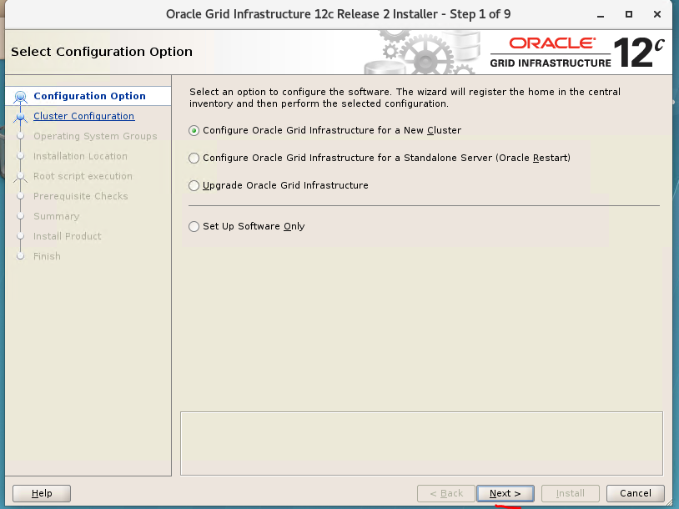

Choose “Configure Oracle Grid infrastructure for a New Cluster”

Click Next

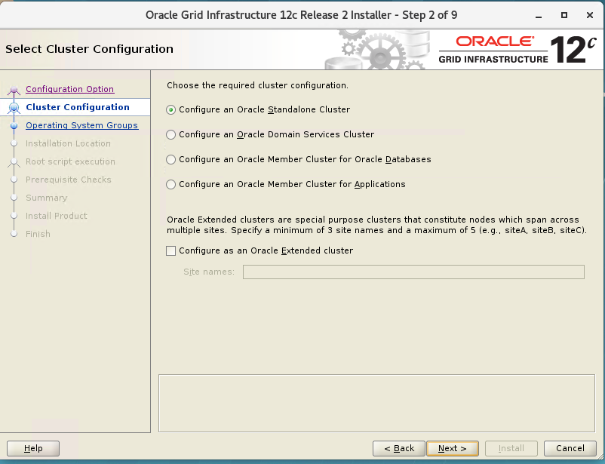

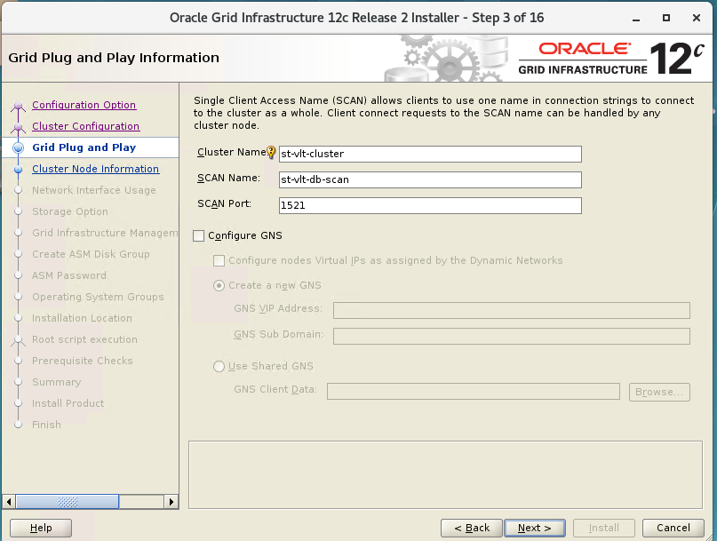

Choose the SCAN name according to the /etc/hosts file

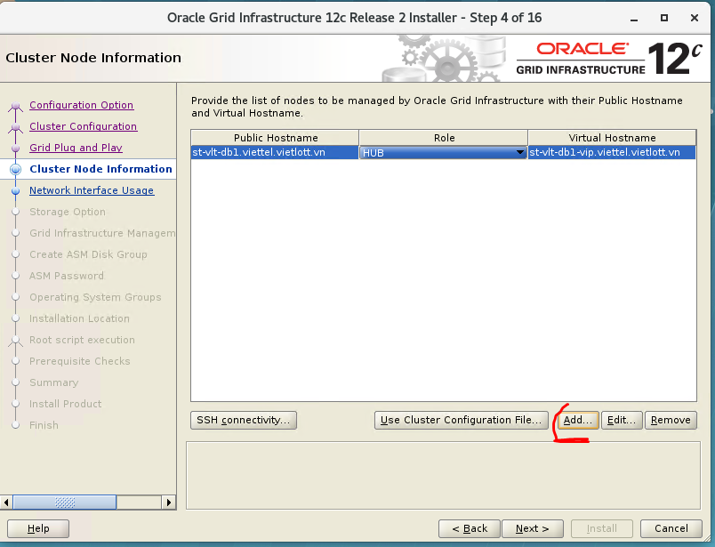

Click Add to add more ASM node

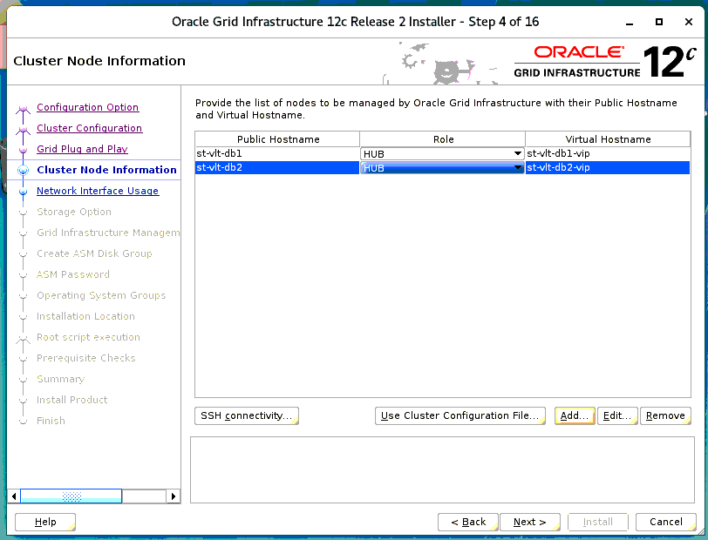

Click next

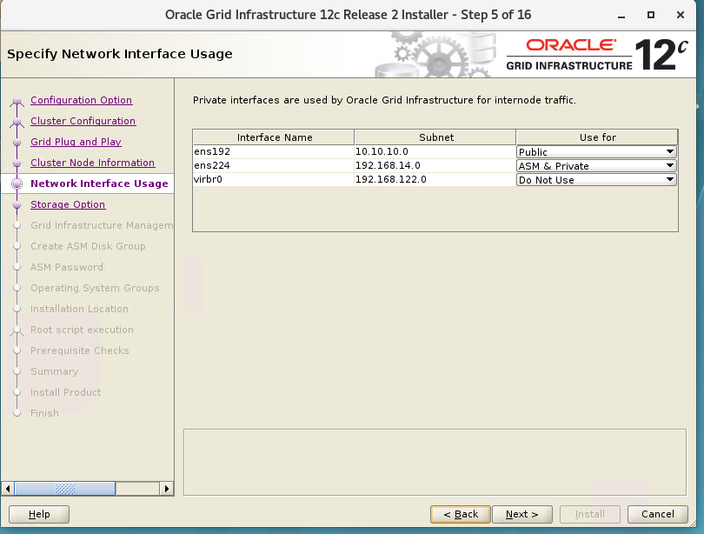

Optional: below menu page may appear:

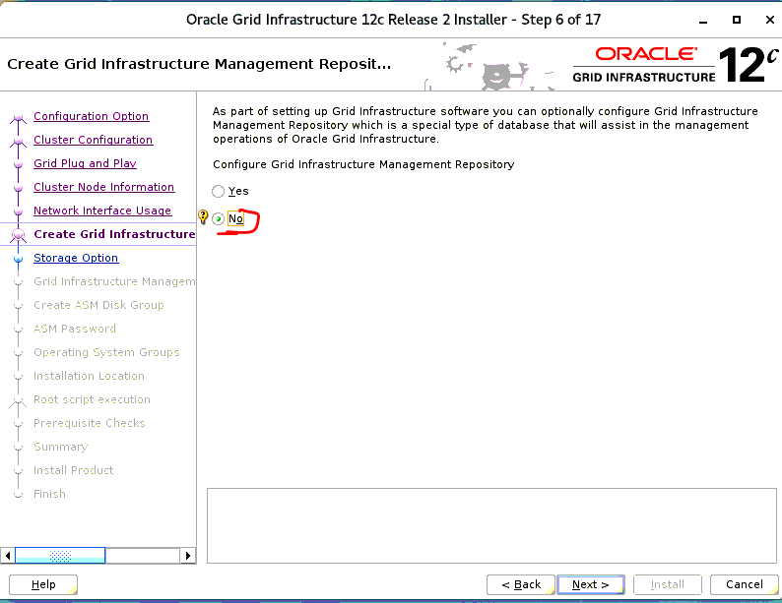

Choose No, then Next

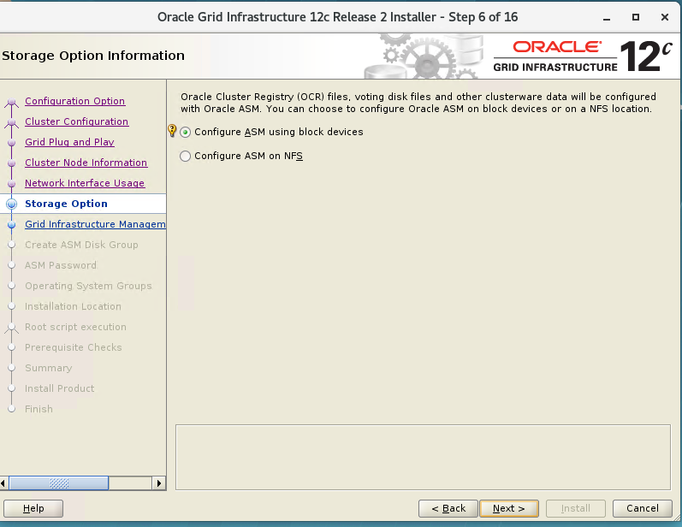

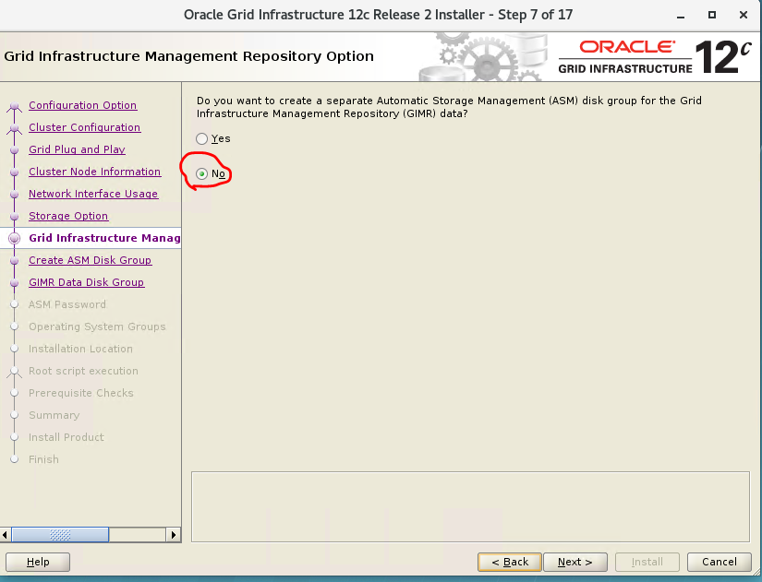

Click Next

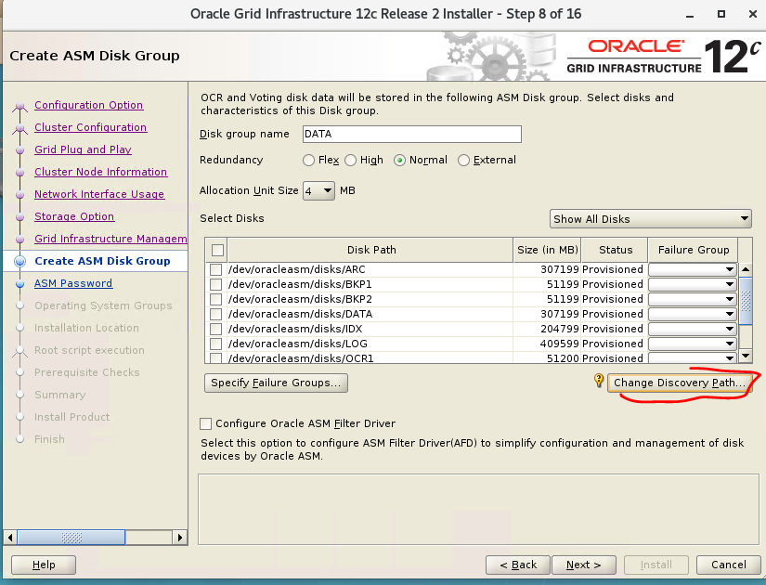

Click Change Discovery Path to: “/dev/oracleasm/disks*”

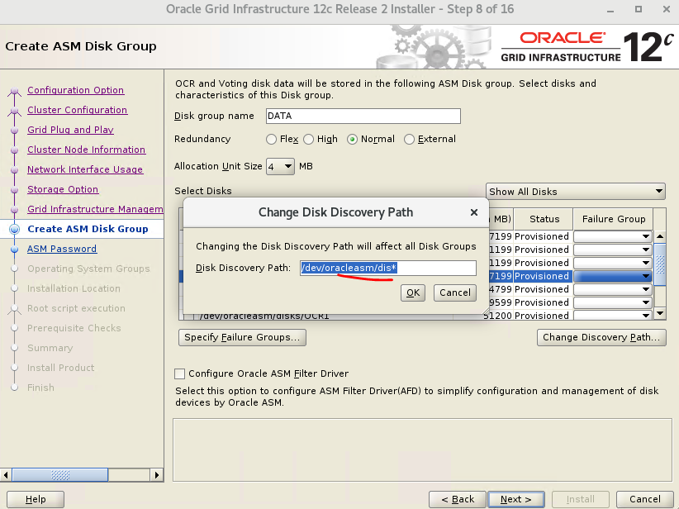

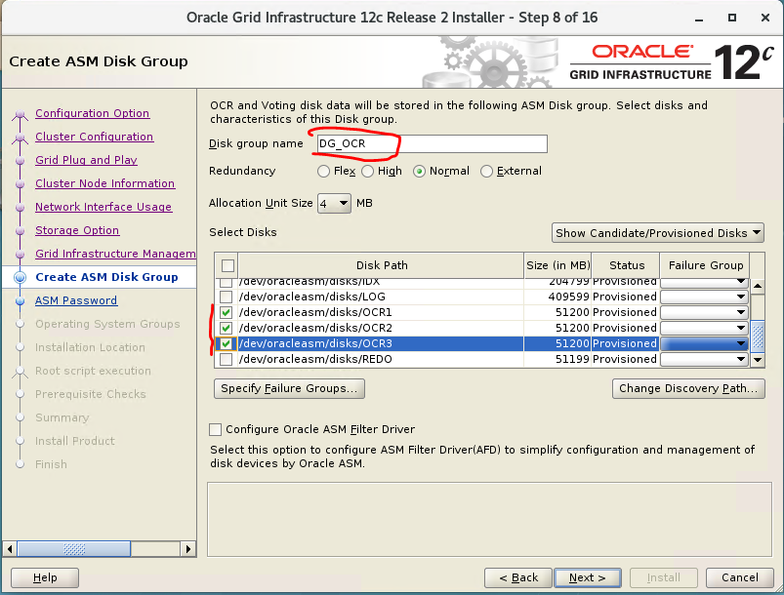

Click Next

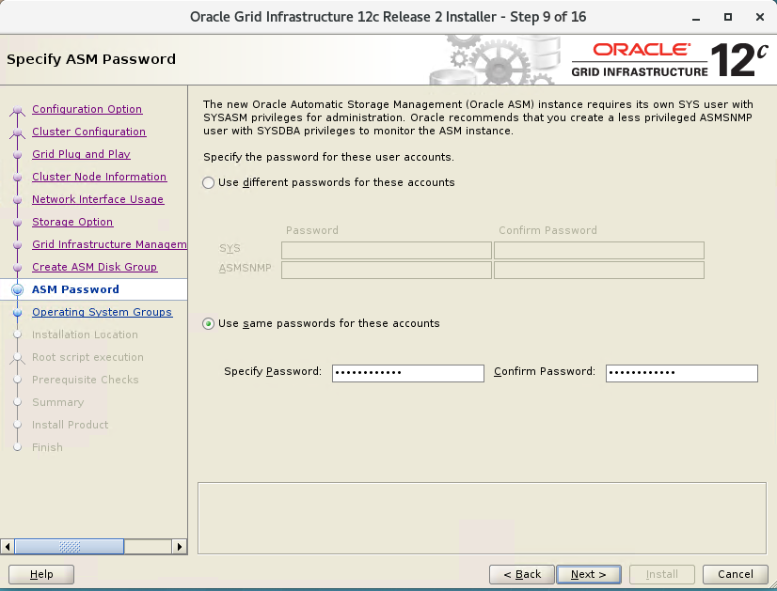

Enter the password: Vietlott1234

Click Next

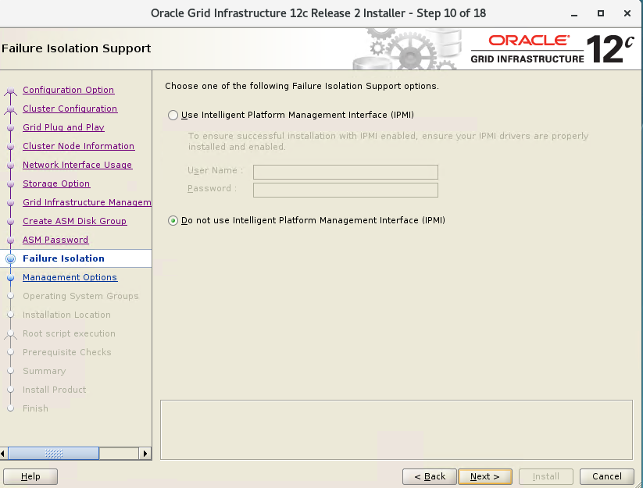

Click next

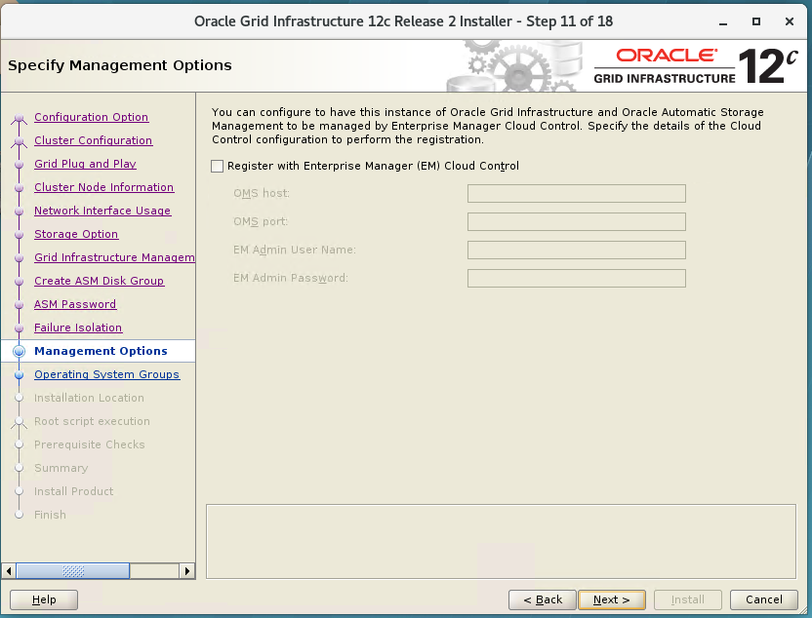

Click Next

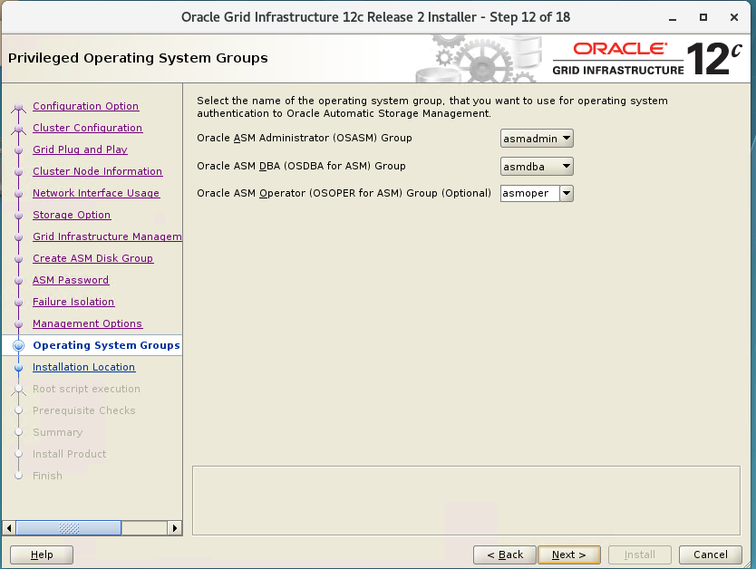

Click Next

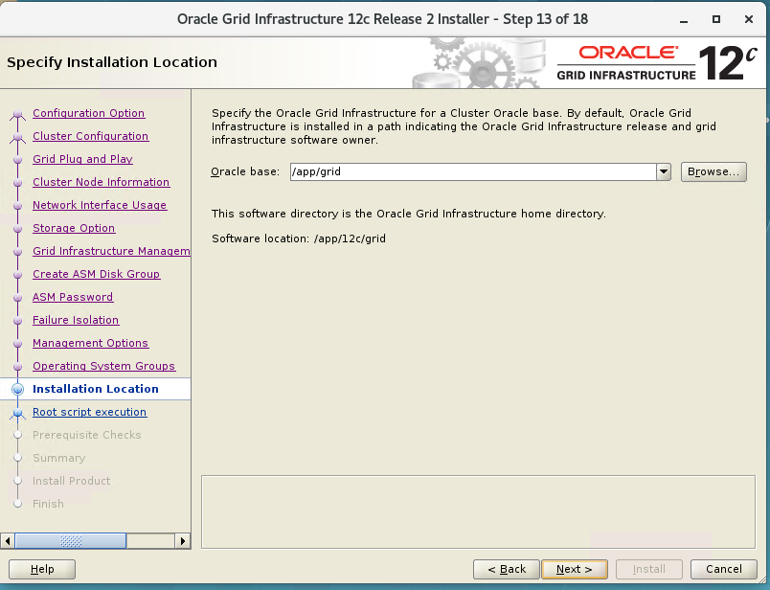

Click Next

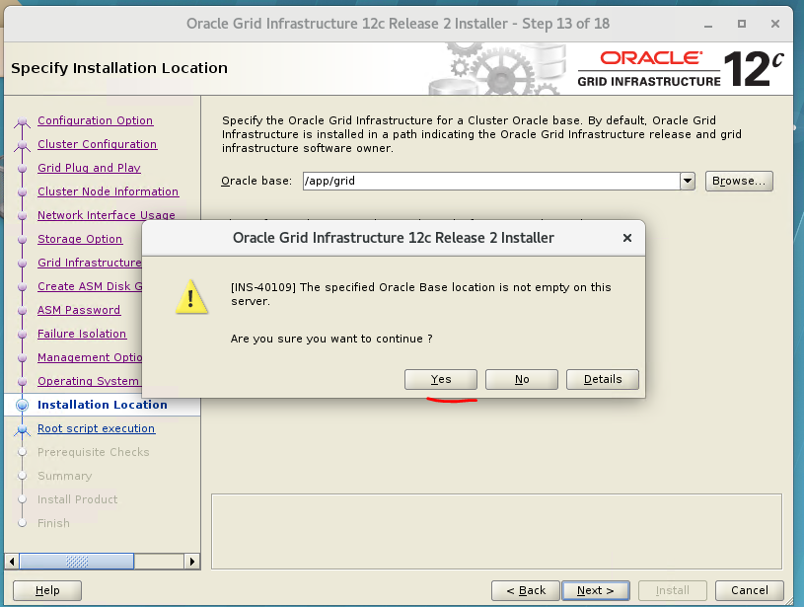

Thực hiện kiểm tra trong thư mục **$ORACLE_BASE.**   
Cần xóa hết tất cả các file ở trong thư mục này

Click yes

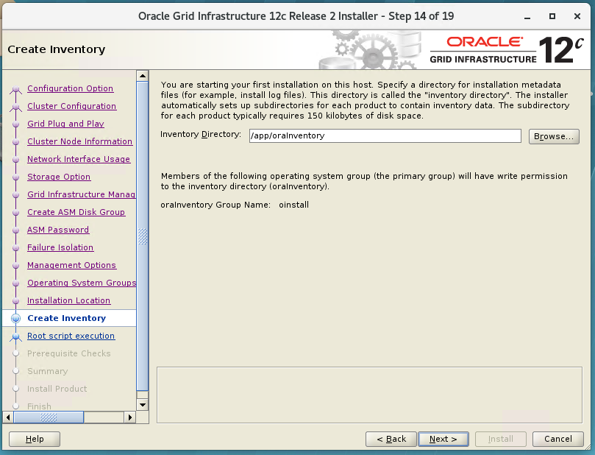

Click Next

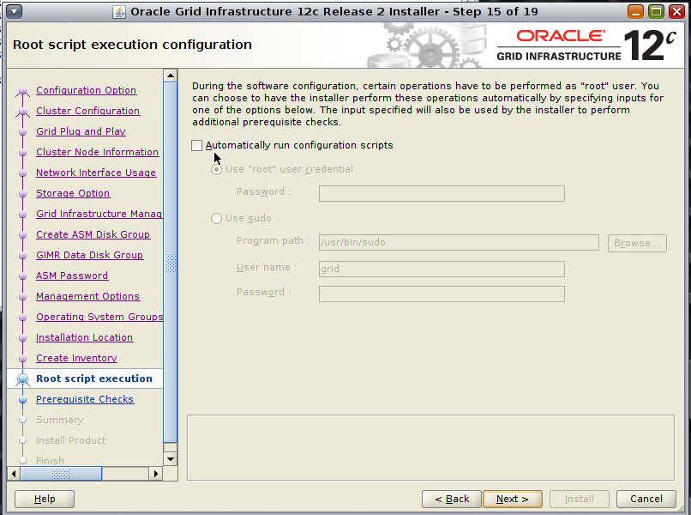

Click Next

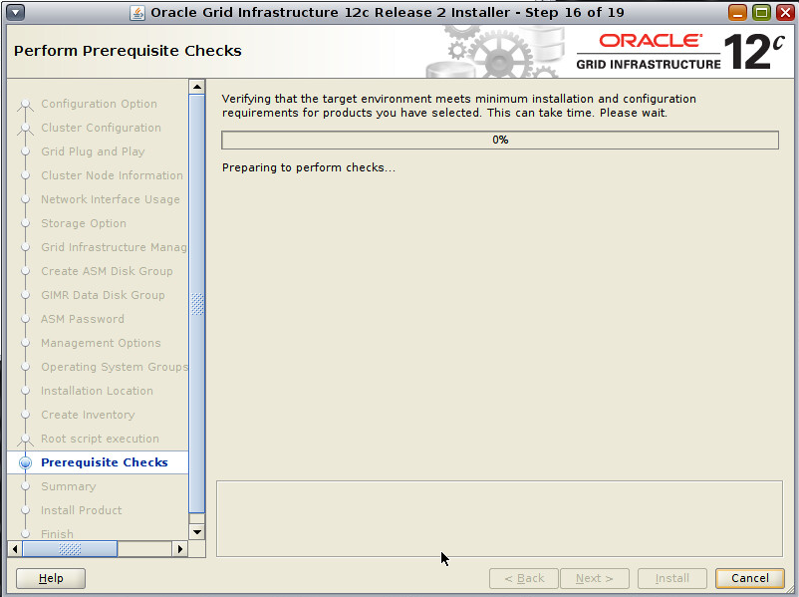

Chờ check thông tin

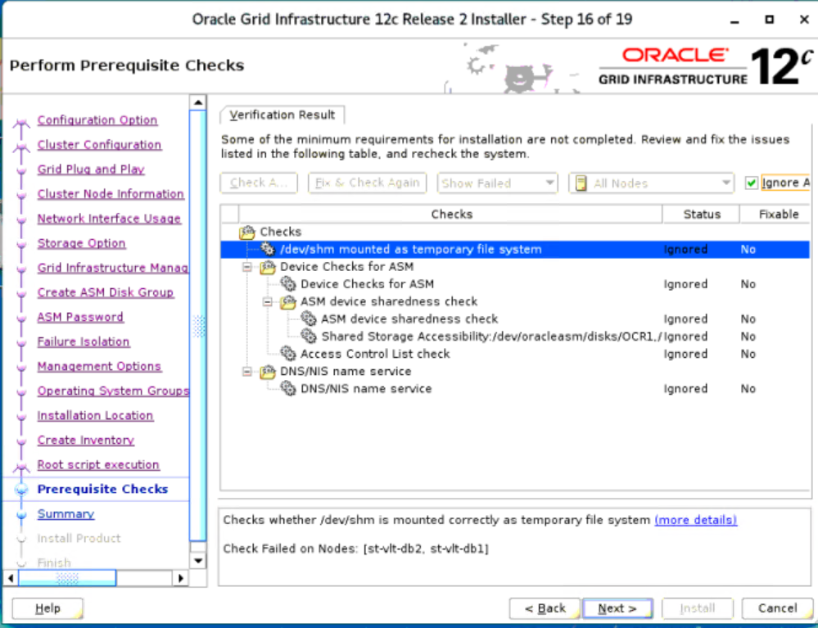

The following check errors are common and may be ignored if verified.

* */dev/shm* mounted as a temporary file system - This is related to a bug Oracle DOC ID: 2065603.1 were the installer is looking for */dev/shm* to be located in */etc/fstab*. Within Red Hat Enterprise Linux 7 *tmpfs* is mounted by default on the OS.
* Network Time Protocol (NTP) - This task verifies cluster time synchornization on clusters. Manually verify that ntp is running on all nodes within the Oracle RAC cluster. If NTP is properly running and configured, this error can be safely ignored.
* Device Checks for ASM - This task checks to verify that the specified devices meet the requiresments for ASM. In this particular case, it is having issues indicating that the */dev/mapper/ocrvote\** devices are not shared across nodes. However, this can be confirmed with multipath -ll that they are. Thus this error can be safely ignored.

Check **Ignore**

Click **Next**

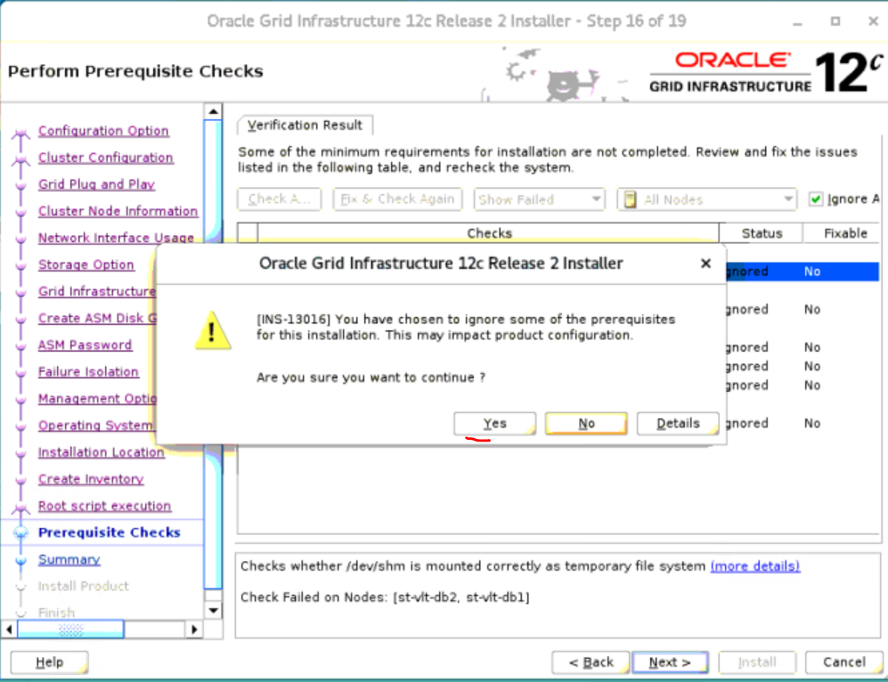

Click Yes

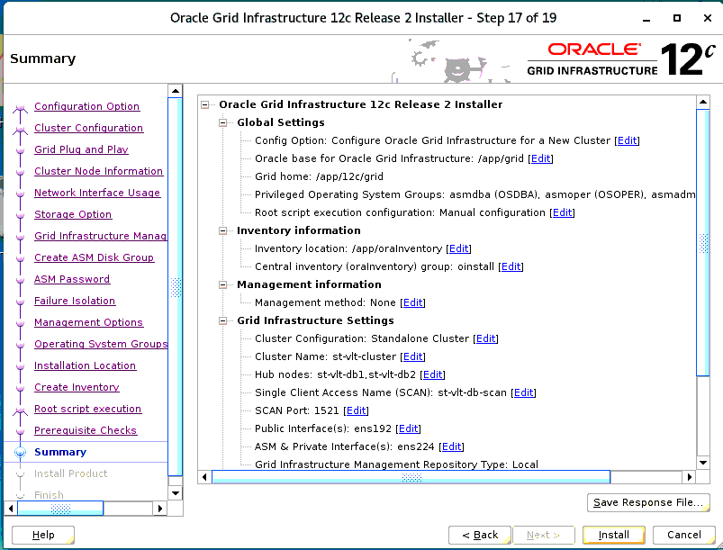

Click Install

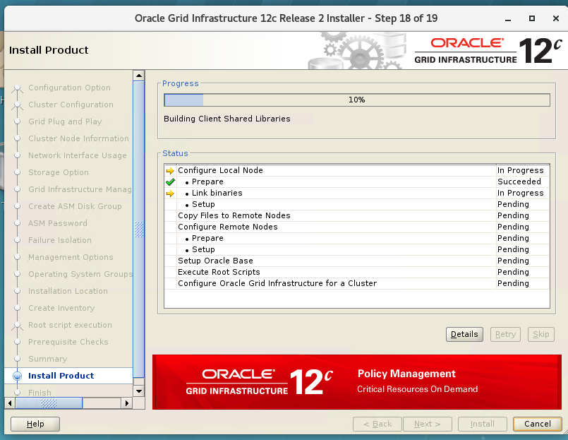

Chờ chạy cài đặt

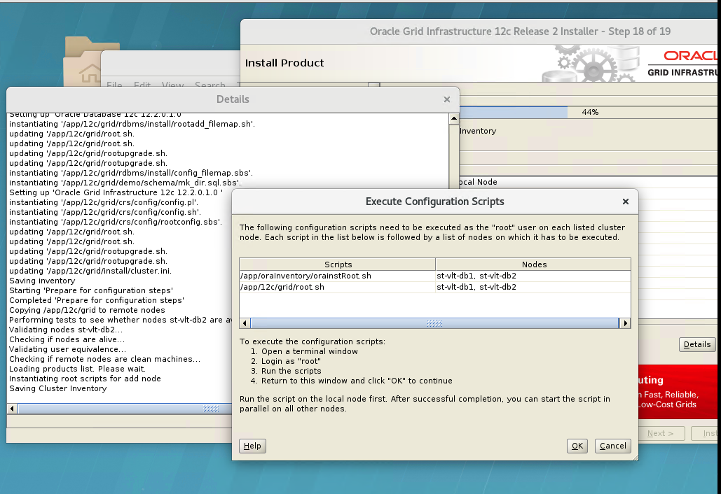

Nếu hiển thị lên Dialog này. Cần chạy 2 script lần lượt trên 2 Node bằng **user Root**

[root@st-vlt-db1 ~]#/app/oraInventory/orainstRoot.sh

[root@st-vlt-db2 ~]#/app/oraInventory/orainstRoot.sh

[root@st-vlt-db1 ~]#/app/12c/grid/root.sh

[root@st-vlt-db2 ~]#/app/12c/grid/root.sh

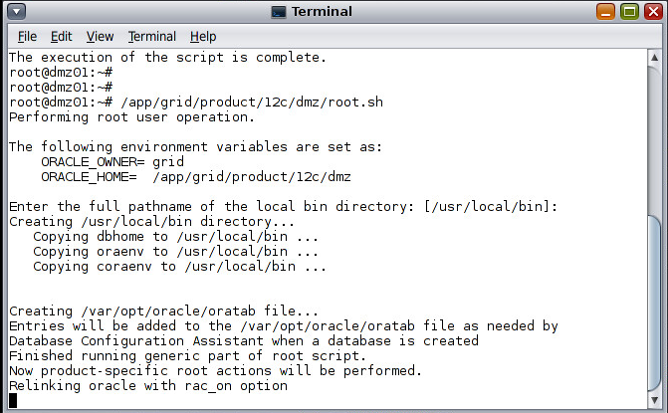

Sau khi chay xong 2 scripts trên.

Click OK để tiếp tục

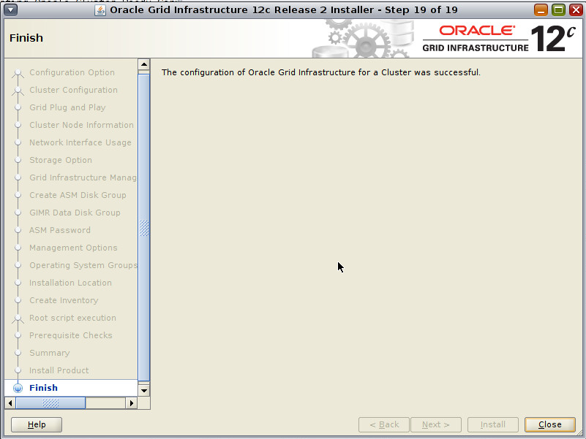

Click Close

Thực hiện cài đặt thành công

1. Remove Grid

1/ Thực hiện trên node st-vlt-db1

User root

[root@st-vlt-db1 grid]# export PATH=/app/12c/grid/perl/bin:$PATH

[root@st-vlt-db1 grid]# cd /app/12c/grid/crs/install/

[root@st-vlt-db1 install]# perl rootcrs.pl -verbose -deconfig

2/ Thực hiện trên node st-vlt-db2

User root

[root@st-vlt-db2 grid]# export PATH=/app/12c/grid/perl/bin:$PATH

[root@st-vlt-db2 grid]# cd /app/12c/grid/crs/install/

[root@st-vlt-db2 install]# perl rootcrs.pl -verbose -deconfig -force

3/ Thực hiện trên node st-vlt-db1 (lastnode)

User root

[root@st-vlt-db2 grid]# export PATH=/app/12c/grid/perl/bin:$PATH

[root@st-vlt-db2 grid]# cd /app/12c/grid/crs/install/

[root@st-vlt-db2 install]# perl rootcrs.pl -verbose -deconfig -force -lastnode

4/ Thực hiện clear disk header được sử dụng trên ASM trên cả 2 node:

User root

#dd if=/dev/zero of=/dev/sdb1 bs=1024 count=100

#dd if=/dev/zero of=/dev/sdc1 bs=1024 count=100

#dd if=/dev/zero of=/dev/sdd1 bs=1024 count=100

5/ Thực hiện delete ASM disks trên node 1

User root

#/usr/sbin/oracleasm deletedisk OCR1

#/usr/sbin/oracleasm deletedisk REDO

#/usr/sbin/oracleasm deletedisk OCR2

#/usr/sbin/oracleasm deletedisk BKP1

#/usr/sbin/oracleasm deletedisk OCR3

#/usr/sbin/oracleasm deletedisk BKP2

#/usr/sbin/oracleasm deletedisk IDX

#/usr/sbin/oracleasm deletedisk ARC

#/usr/sbin/oracleasm deletedisk DATA

#/usr/sbin/oracleasm deletedisk LOG

Check lại để đảm bảo ASM disks đã được xóa trên cả 2 node

User root

[root@st-vlt-**db1** grid]# oracleasm scandisks

[root@st-vlt-**db1** grid]# oracleasm listdisks

[root@st-vlt-**db2** grid]# oracleasm scandisks

[root@st-vlt-**db2** grid]# oracleasm listdisks

5/ Xóa các folder Home, Base, oraInventory của grid trên cả 2 node

User root

[root@st-vlt-**db1** grid]# cd /app/oraInventory/

[root@st-vlt-**db1** grid]# rm –rf *

[root@st-vlt-**db1** grid]# cd /app/grid

[root@st-vlt-**db1** grid]# rm –rf *

[root@st-vlt-**db1** grid]# cd /app/12c/grid

[root@st-vlt-**db1** grid]# rm –rf *

[root@st-vlt-**db1** grid]# ls –lrtha

[root@st-vlt-**db2** grid]# cd /app/oraInventory/

[root@st-vlt-**db2** grid]# rm –rf *

[root@st-vlt-**db2** grid]# cd /app/grid

[root@st-vlt-**db2** grid]# rm –rf *

[root@st-vlt-**db2** grid]# cd /app/12c/grid

[root@st-vlt-**db2** grid]# rm –rf *

[root@st-vlt-**db2** grid]# ls –lrtha

1. Add Diskgroup

Open GUI on 1st node

su – grid

grid@st-vlt-db1:~$ export ORACLE_SID=+ASM

grid@st-vlt-db1:~$ asmca

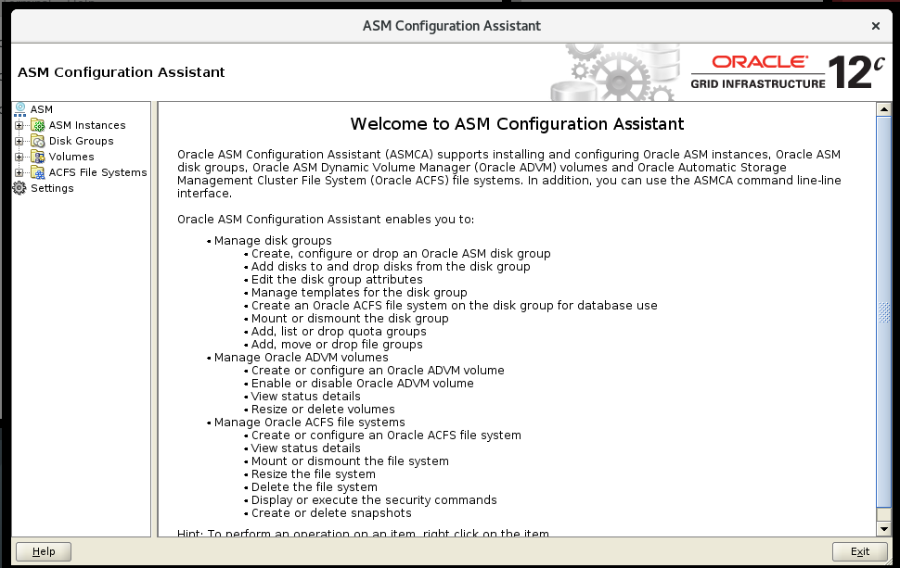

Click **Disk Groups**

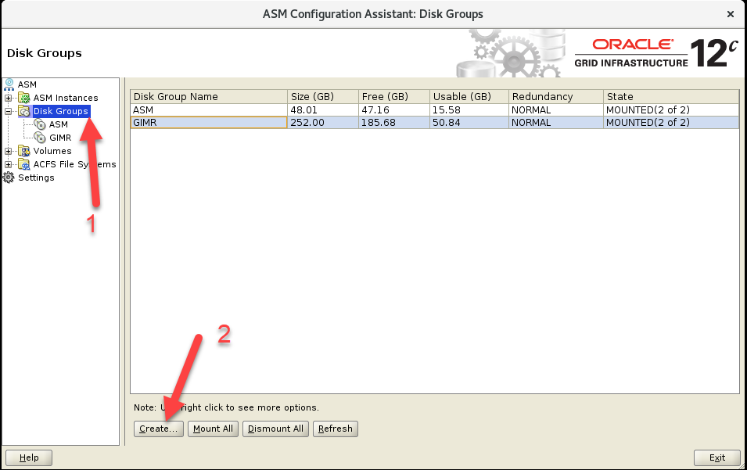

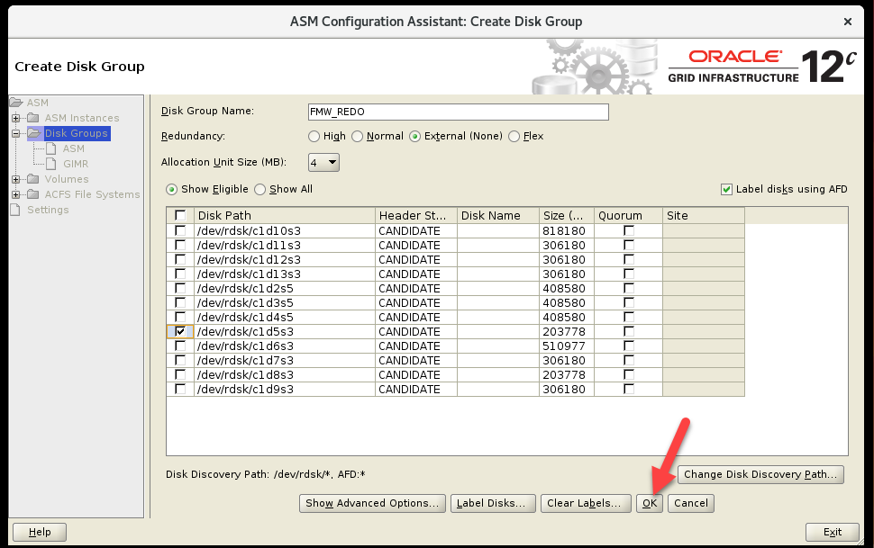

Đặt tên và chọn disk

**Note** : Nếu add disk group cho Database thì chỉ cần dùng External để tăng performance.   
Không cần dùng các option khác cho tốn Disk

Click **OK**

Kết quả

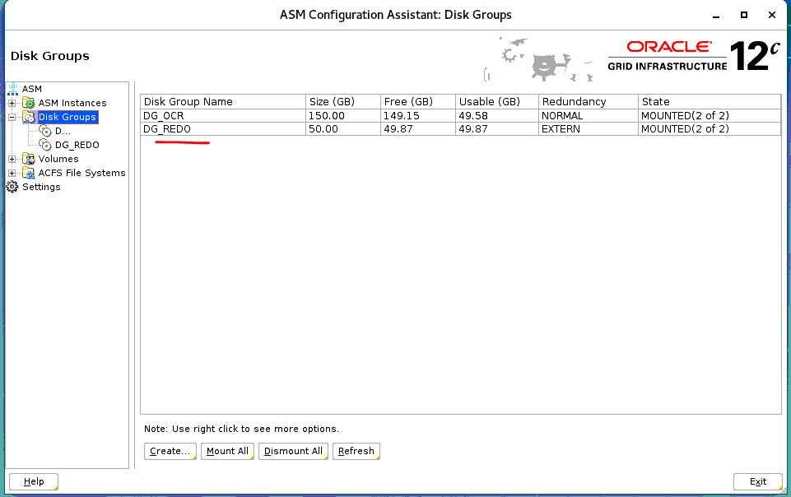

Làm tương tự cho các Disk group khác theo quy hoạch. File VDI_CNI_Customer Network Information.

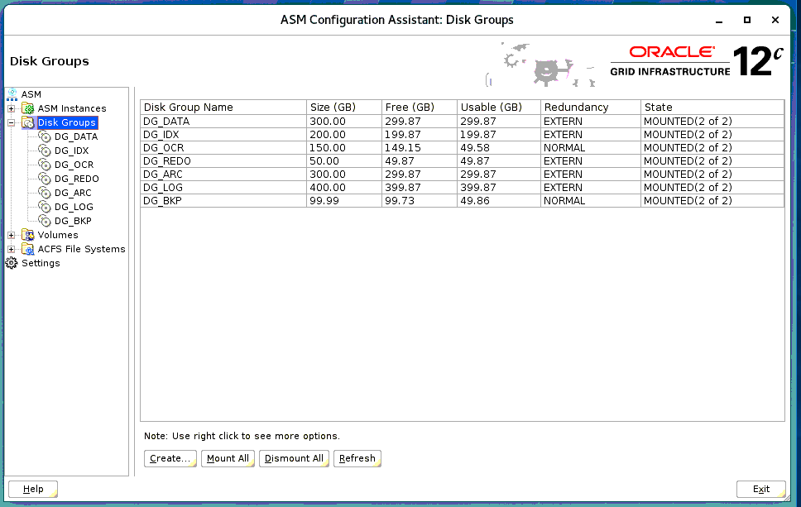

1. Monitoring Grid

asmcmd lsdsk -k -g

grid@st-vlt-db1:~$ srvctl status asm

grid@st-vlt-db1:~$ crsctl status resource -n st-vlt-db1

grid@st-vlt-db1:~$ asmcmd -p

ASMCMD [+] > lsdg

State Type Rebal Sector Logical_Sector Block AU Total_MB Free_MB Req_mir_free_MB Usable_file_MB Offline_disks Voting_files Name

MOUNTED NORMAL N 512 512 4096 4194304 1225740 1225332 408580 408376 0 N APPDATA/

MOUNTED NORMAL N 512 512 4096 4194304 49164 48296 16388 15954 0 Y ASM/

MOUNTED EXTERN N 512 512 4096 4194304 203776 203644 0 203644 0 N FMW_ARC/

MOUNTED EXTERN N 512 512 4096 4194304 306180 306048 0 306048 0 N FMW_BKP/

MOUNTED EXTERN N 512 512 4096 4194304 510976 510844 0 510844 0 N FMW_DATA/

MOUNTED EXTERN N 512 512 4096 4194304 203776 203644 0 203644 0 N FMW_REDO/

MOUNTED NORMAL N 512 512 4096 4194304 258048 190072 86016 52028 0 N GIMR/

MOUNTED EXTERN N 512 512 4096 4194304 306180 306048 0 306048 0 N VAS_ARC/

MOUNTED EXTERN N 512 512 4096 4194304 306180 306048 0 306048 0 N VAS_BKP/

MOUNTED EXTERN N 512 512 4096 4194304 818180 818048 0 818048 0 N VAS_DATA/

MOUNTED EXTERN N 512 512 4096 4194304 306180 306048 0 306048 0 N VAS_IDX/

MOUNTED EXTERN N 512 512 4096 4194304 306180 306048 0 306048 0 N VAS_REDO/

ASMCMD [+] > lsdsk

Path

AFD:APPDATA1

AFD:APPDATA2

AFD:APPDATA3

AFD:ASM1

AFD:ASM2

AFD:ASM3

AFD:FMW_ARC1

AFD:FMW_BKP1

AFD:FMW_DATA1

AFD:FMW_REDO1

AFD:GIMR1

AFD:GIMR2

AFD:GIMR3

AFD:VAS_ARC1

AFD:VAS_BKP1

AFD:VAS_DATA1

AFD:VAS_IDX1

AFD:VAS_REDO1

ASMCMD [+] > iostat

Group_Name Dsk_Name Reads Writes

APPDATA APPDATA1 40960 4096

APPDATA APPDATA2 16384 4096

APPDATA APPDATA3 946176 4096

ASM ASM1 945152 4096

ASM ASM2 65536 4096

ASM ASM3 49152 4096

FMW_ARC FMW_ARC1 974848 4096

FMW_BKP FMW_BKP1 974848 4096

FMW_DATA FMW_DATA1 974848 4096

FMW_REDO FMW_REDO1 974848 4096

GIMR GIMR1 929792 4096

GIMR GIMR2 49152 4096

GIMR GIMR3 24576 4096

VAS_ARC VAS_ARC1 974848 4096

VAS_BKP VAS_BKP1 974848 4096

VAS_DATA VAS_DATA1 974848 4096

VAS_IDX VAS_IDX1 974848 4096

VAS_REDO VAS_REDO1 974848 4096

ASMCMD [+] >

ps -ef|grep d.bin

crs_stat -t

crsctl check cluster -all

crsctl check crs

crsctl stat res -t

crsctl stat res -t -init

crsctl query calog

srvctl config scan

srvctl config scan_listener

srvctl config listener

sqlplus / as sysasm

SELECT name AS diskgroup, substr(compatibility,1,12) AS asm_compat,

substr(database_compatibility,1,12) AS db_compat FROM V$ASM_DISKGROUP;

DISKGROUP ASM_COMPAT DB_COMPAT

------------------------------ ------------ ------------

DATA 12.1.0.0.0 12.1.0.0.0

FRA 12.1.0.0.0 12.1.0.0.0

#Example 6-3 Viewing disks in disk groups with V$ASM_DISK

An example of the use of the V$ASM_DISK and V$ASM_DISKGROUP views is shown in this example. This example displays the disks associated with a disk group, plus the mount status, state, and failure group of the disks.

SELECT SUBSTR(dg.name,1,16) AS diskgroup, SUBSTR(d.name,1,16) AS asmdisk,

d.mount_status, d.state, SUBSTR(d.failgroup,1,16) AS failgroup

FROM V$ASM_DISKGROUP dg, V$ASM_DISK d WHERE dg.group_number = d.group_number;

#Example 6-5 Viewing disk group clients with V$ASM_CLIENT

An example of the use of the V$ASM_CLIENT and V$ASM_DISKGROUP views on an Oracle ASM instance is shown in this example, which displays disk groups with information about the connected database client instances.

SELECT dg.name AS diskgroup, SUBSTR(c.instance_name,1,12) AS instance,

SUBSTR(c.db_name,1,12) AS dbname, SUBSTR(c.SOFTWARE_VERSION,1,12) AS software,

SUBSTR(c.COMPATIBLE_VERSION,1,12) AS compatible

FROM V$ASM_DISKGROUP dg, V$ASM_CLIENT c

WHERE dg.group_number = c.group_number;

select name, compatibility from v$asm_diskgroup;

adrci

**CRS Stop and Start**

[root@node2 ~] cd $GRID_HOME/bin  
[root@node2 bin] ./crsctl stop cluster -all  
[root@node2 bin] ./crsctl start cluster -all

**Check CRS**

[root@node2 bin] ./crsctl check crs  
[root@node2 bin] ./crsctl check cluster -all  
**Note :** All services have to be up.

**Run root.sh**

**Note :** If Cluster Virtual IPS not received, You can run root.sh  
[root@node2 ~] cd $GRID_HOME  
[root@node2 ~] ./root.sh  
[root@node2 ~] cd $ORACLE_HOME  
[root@node2 ~] ./root.sh

**Various CRS Control Commands**

crs_stat -t  
crsctl stop has  
crsctl start has  
crsctl start resource   
crsctl stop resource   
crsctl status server

## tail -f /app/grid/base/diag/crs/`hostname`/crs/trace/alert.log

### Checks network and storage on the specified nodes in the cluster before installing Oracle software. This command also checks for supported storage types and checks each one for sharing.

cluvfy stage -post hwos -n st-vlt-db1,testbed02 -verbose

## Checks the compatibility and properties of the specified nodes against a reference node.

cluvfy comp peer -n st-vlt-db1,testbed02 -verbose

##Checks the integrity of the Oracle High Availability Services daemon.

cluvfy comp ohasd -n all -verbose

## Checks the integrity of the cluster manager subcomponent, or Oracle Cluster Synchronization Services (CSS), on the nodes in the node list.

cluvfy comp clumgr -n all -verbose

## Checks the integrity of Grid Plug and Play on a list of nodes in a cluster.

cluvfy comp gpnp -n all -verbose

cluvfy comp nodeapp -n all –verbose

<https://www.hhutzler.de/blog/troubleshooting-clusterware-startup-problems/>

1. Install Oracle Database
   1. Tạo folder

root@st-vlt-db1:/# mkdir -p /app/oracle

root@st-vlt-db1:/# mkdir -p /app/oraInventory

root@st-vlt-db1:/# mkdir -p /app/oracle/product/12c/vietlott_db

root@st-vlt-db1:/# chown -R oracle:oinstall /app/oracle

root@st-vlt-db1:/# chown -R oracle:oinstall /app/oraInventory/

root@st-vlt-db1:/# chmod -R 755 /app/oracle

root@st-vlt-db1:/# chmod -R 755 /app/oraInventory/

* 1. Copy file lên folder home của user oracle

Unzip file

su – root

cd /app/oracle/product/12c/vietlott_db

unzip V839960-01.zip

chown -R oracle:oinstall /app/oracle/product/12c/vietlott_db

chmod -R 755 /app/oracle/product/12c/vietlott_db

* 1. Passwordless

Nếu ở bước cài đặt Grid chưa thực hiện set passwordless cho user Oracle thì trong package cài đặt Database cũng có file

Trước khi thực hiện chạy script cài đặt password thì cần thực hiện ssh từ các hosts với nhau trước.

oracle@st-vlt-db1:~$

oracle@st-vlt-db1:~$ cd database/sshsetup/

oracle@st-vlt-db1:~/database/sshsetup$ ./sshUserSetup.sh -user oracle -hosts "dmz01 dmz02" -noPromptPassphrase -confirm -advanced

**Note** :   
- Password : nhập password của user  
- cd về thư mục $HOME của user

setup vncserver

[oracle@st-vlt-db1 database]$ vncserver

You will require a password to access your desktops.

Password:

Verify:

Would you like to enter a view-only password (y/n)? n

A view-only password is not used

xauth: file /home/oracle/.Xauthority does not exist

New 'st-vlt-db1:2 (oracle)' desktop is st-vlt-db1:2

Creating default startup script /home/oracle/.vnc/xstartup

Creating default config /home/oracle/.vnc/config

Starting applications specified in /home/oracle/.vnc/xstartup

Log file is /home/oracle/.vnc/st-vlt-db1:2.log

[oracle@st-vlt-db1 database]$

123456a@

* 1. Install

Chay script = user oracle trên vncviewer, open terminal

oracle@st-vlt-db1:~$

oracle@st-vlt-db1:~$ cd /app/setup/oracle/database  
oracle@st-vlt-db1:~/database$ ./runInstaller

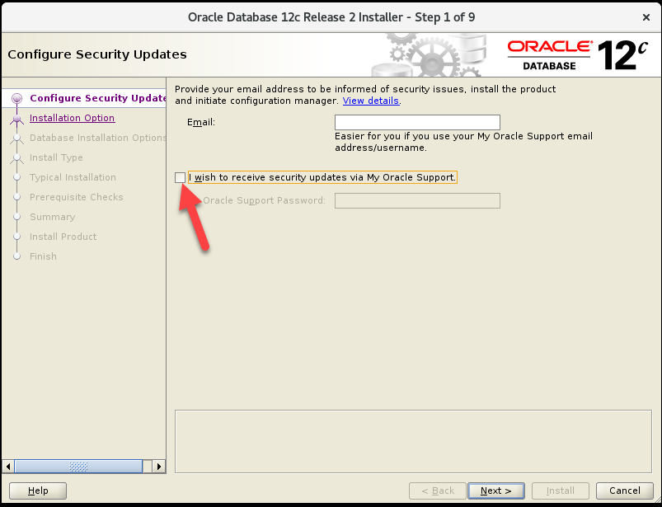

Uncheck and Click Next

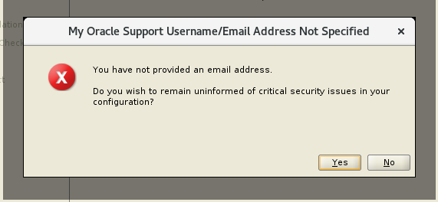

Click Yes

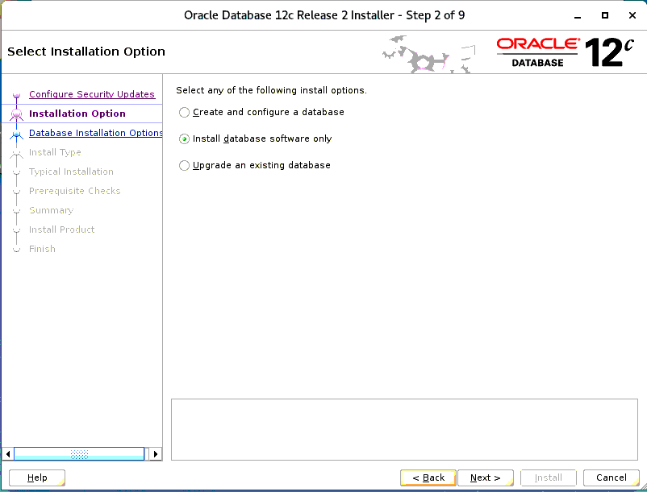

Click Next

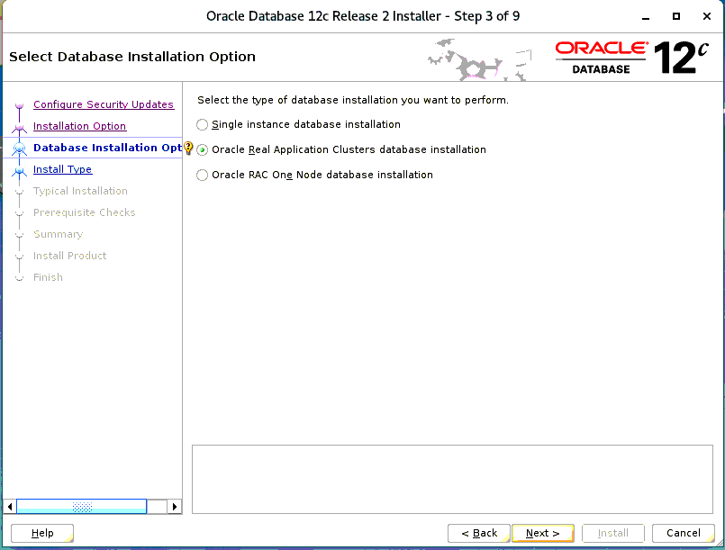

Click Next

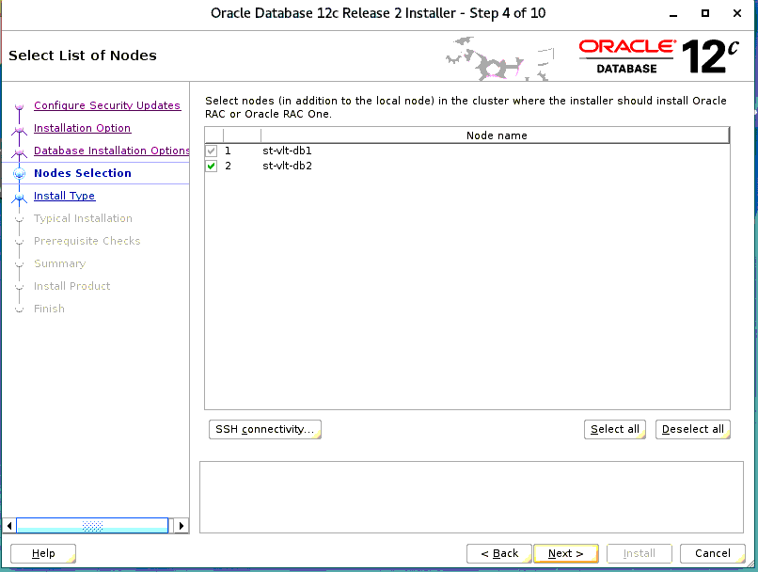

Click Next

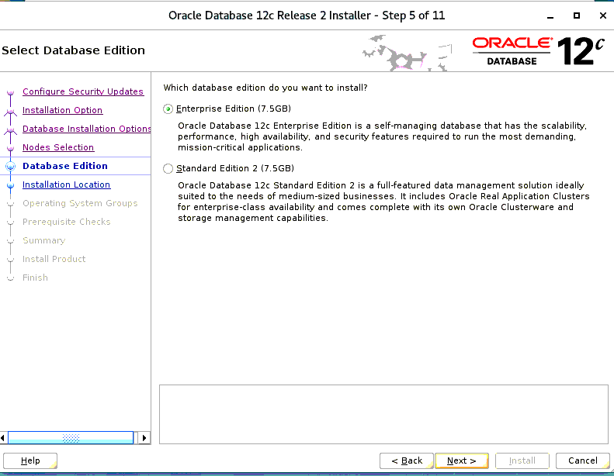

Choose Enterprise Edition, Click Next

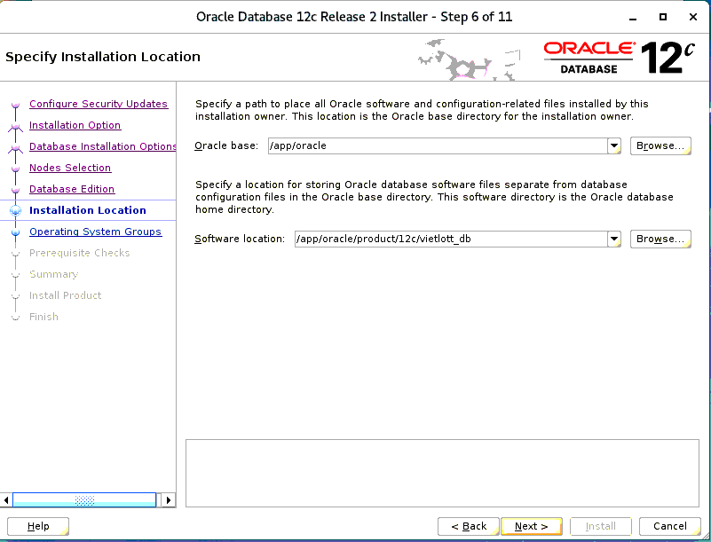

Click Next

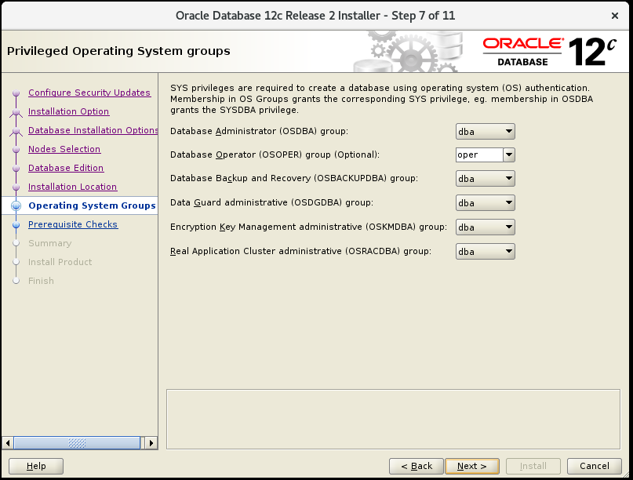

Click Next

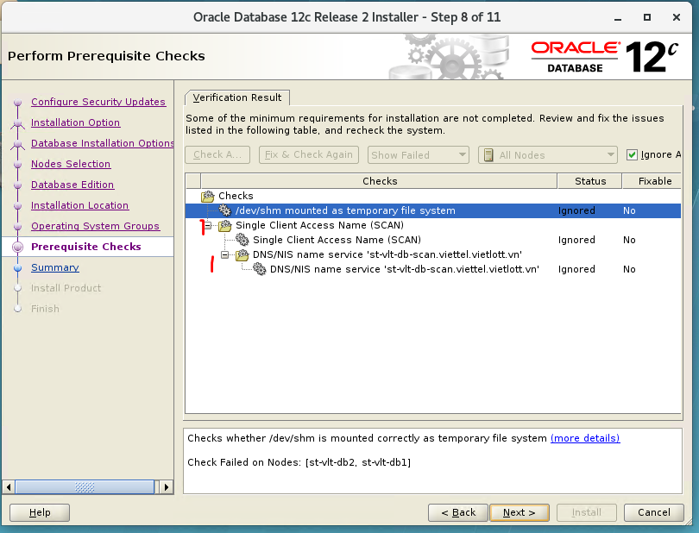

For above errors, we can ignored and then click Next

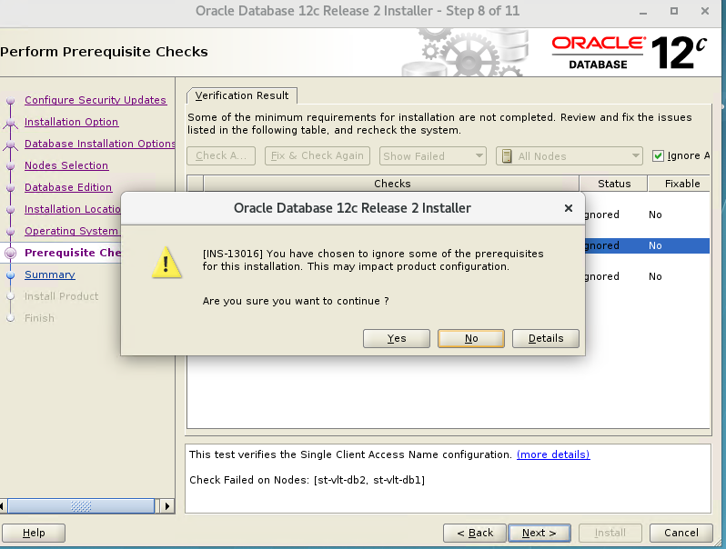

Click Yes

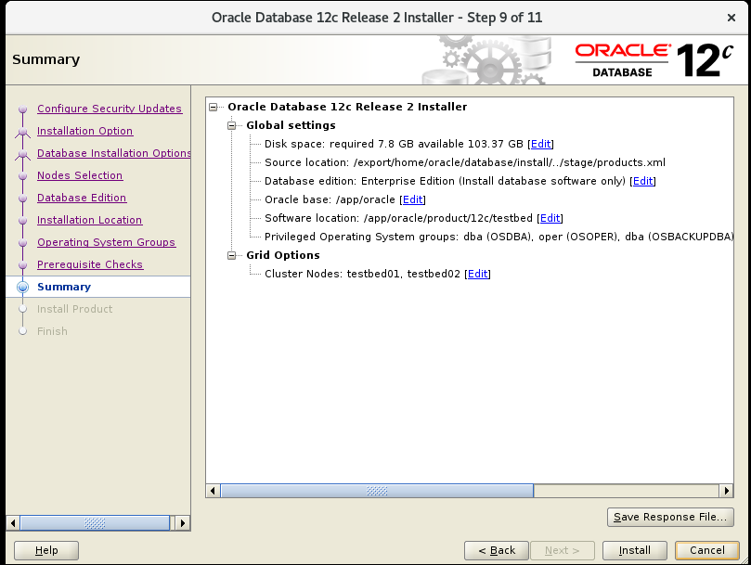

Check infor again

Click Install

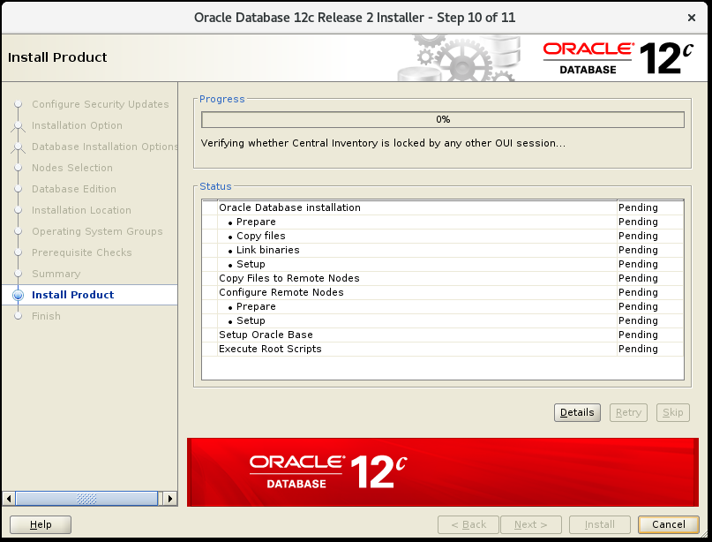

Waitting…..

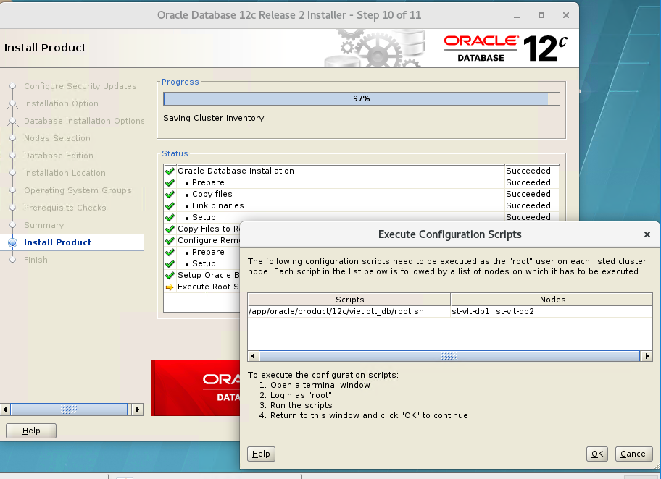

Khi hiển thị Dialog này. Cần chạy script trên 2 nodes.

Sử dụng user **root** để chạy script này.

Không cần thay đổi path.

Enter

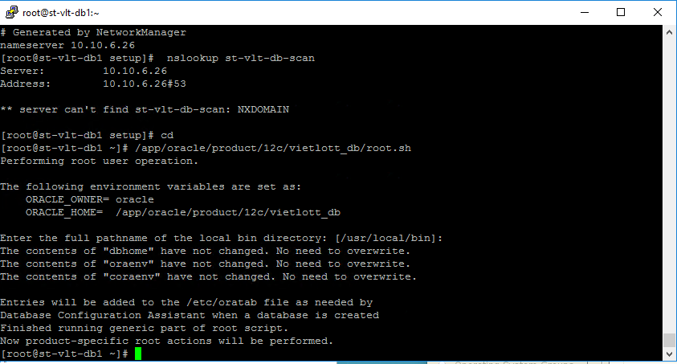

Thực hiện tương tự trên node02

Sau khi thực hiện xong trên 2 nodes thì click OK

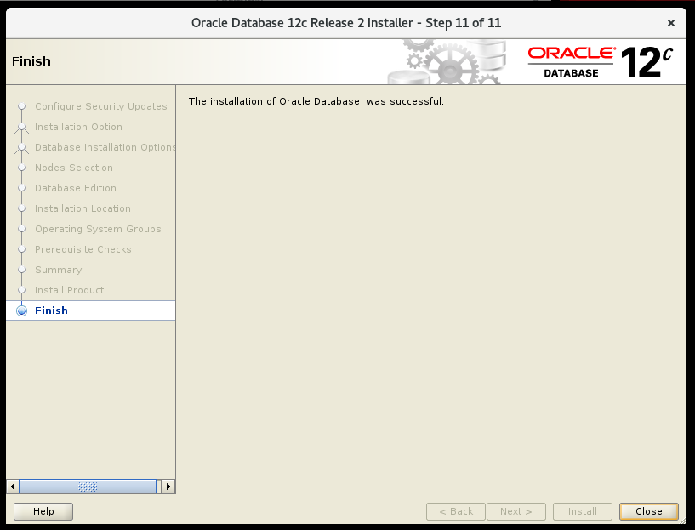

Click Close

Cài đặt thành công.

* 1. Create Oracle Database on RAC
* Set permission oracle (set on two nodes)

root@st-vlt-db1:/app/oracle/product/12c/vietlott_db/bin# pwd /app/oracle/product/12c/vietlott_db/bin/

root@st-vlt-db1:/app/oracle/product/12c/vietlott_db/bin# chmod 6751 oracle

root@st-vlt-db1:/app/oracle/product/12c/vietlott_db/bin#

root@st-vlt-db1:/app/oracle/product/12c/vietlott_db/bin# ls -alrt oracle

-rwsr-s--x 1 oracle oinstall 493203728 Aug 13 15:40 oracle

root@st-vlt-db1:/app/oracle/product/12c/vietlott_db/bin# stat -c "%a" oracle

6751

root@st-vlt-db2:/app/oracle/product/12c/vietlott_db/bin# pwd

/app/oracle/product/12c/vietlott_db/bin

root@st-vlt-db2:/app/oracle/product/12c/vietlott_db/bin# cd /app/oracle/product/12c/vietlott_db/bin

root@st-vlt-db2:/app/oracle/product/12c/vietlott_db/bin# chmod 6751 oracle

root@st-vlt-db2:/app/oracle/product/12c/vietlott_db/bin# ls -alrt oracle

-rwsr-s--x 1 grid oinstall 449832488 Aug 12 16:17 oracle

root@st-vlt-db1:/app/oracle/product/12c/vietlott_db/bin# stat -c "%a" oracle

6751

root@st-vlt-db2:/app/oracle/product/12c/vietlott_db/bin# pwd

/app/oracle/product/12c/vietlott_db/bin

root@st-vlt-db2:/app/oracle/product/12c/vietlott_db/bin#

* start dbca in vncviewer

root@st-vlt-db1:~# su - oracle

Oracle Corporation SunOS 5.11 11.4 Aug 2018

oracle@st-vlt-db1:~$ sqlplus -v

SQL*Plus: Release 12.2.0.1.0 Production

[oracle@st-vlt-db1 bin]$ env | grep ORAC

ORACLE_SID=vietlottb1

ORACLE_BASE=/app/oracle

ORACLE_TERM=xterm

ORACLE_HOME=/app/oracle/product/12c/vietlott_db   
oracle@st-vlt-db1:~$ dbca

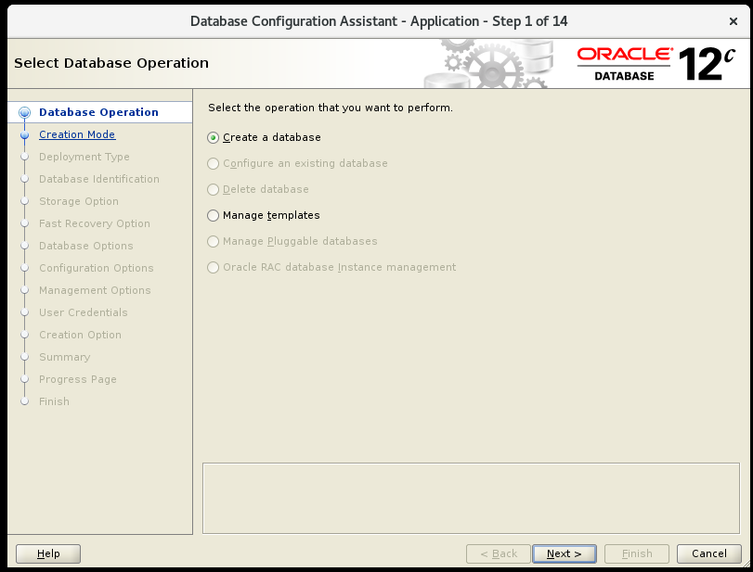

Click Next

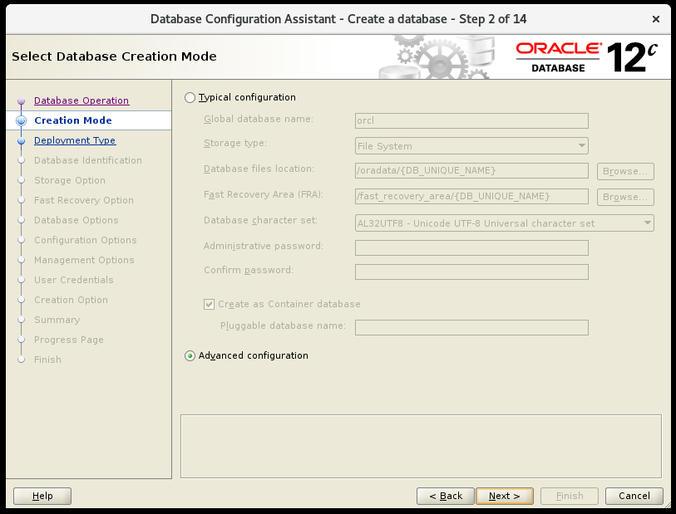

Click Next

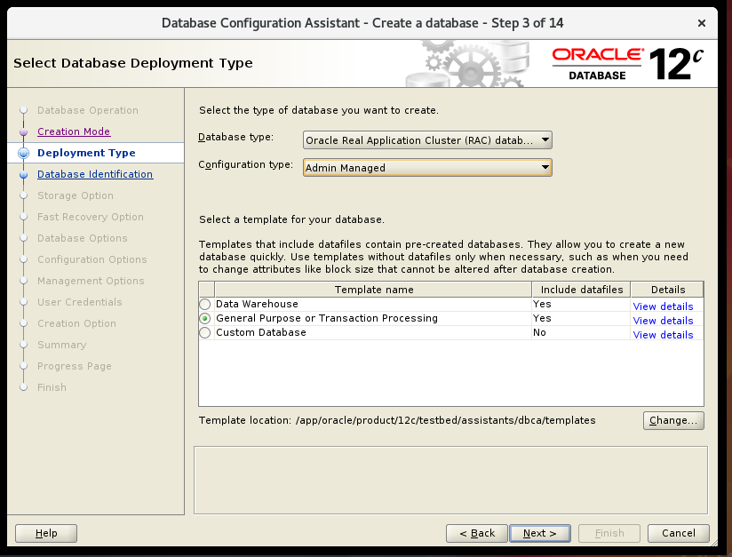

Click Next

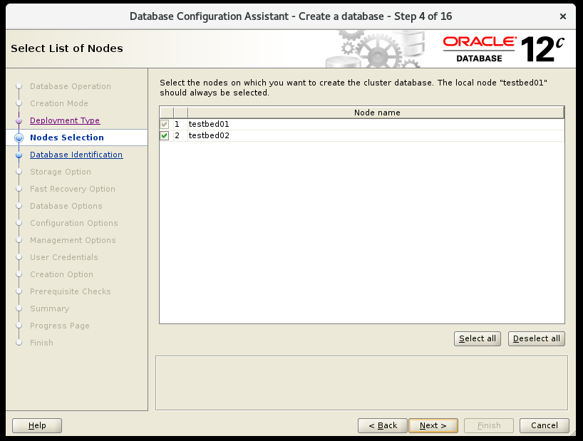

Click Next

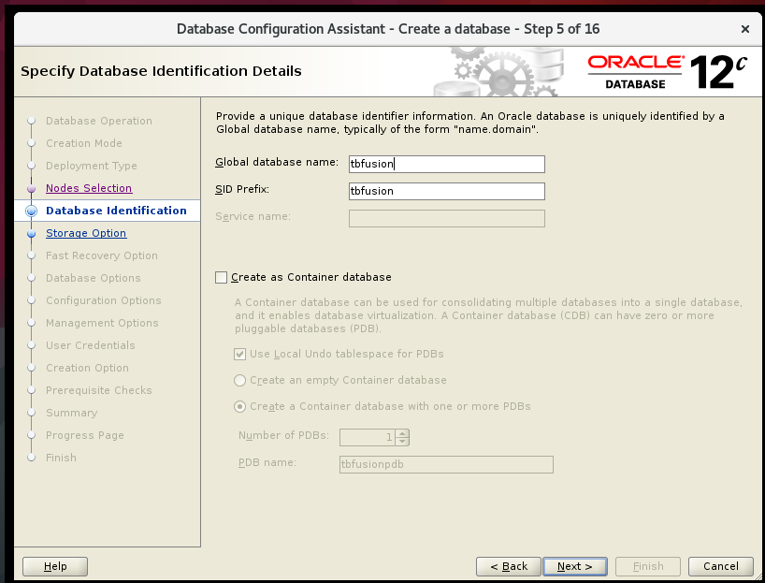

Click next

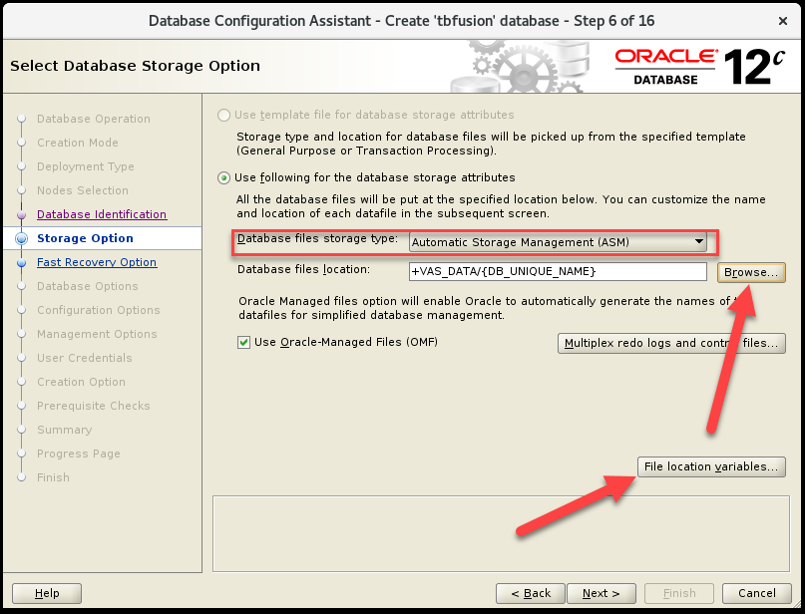

Database files storage type : chọn **Automatic Storage Management (ASM)**

Click **Browser**

Chọn Disk Groups tương ứng

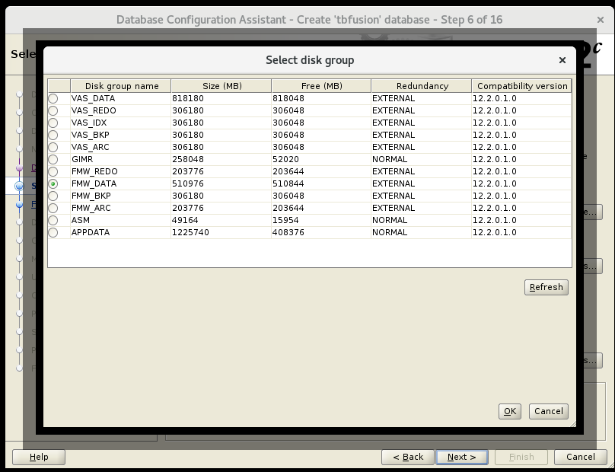

Click OK

Click File location variables

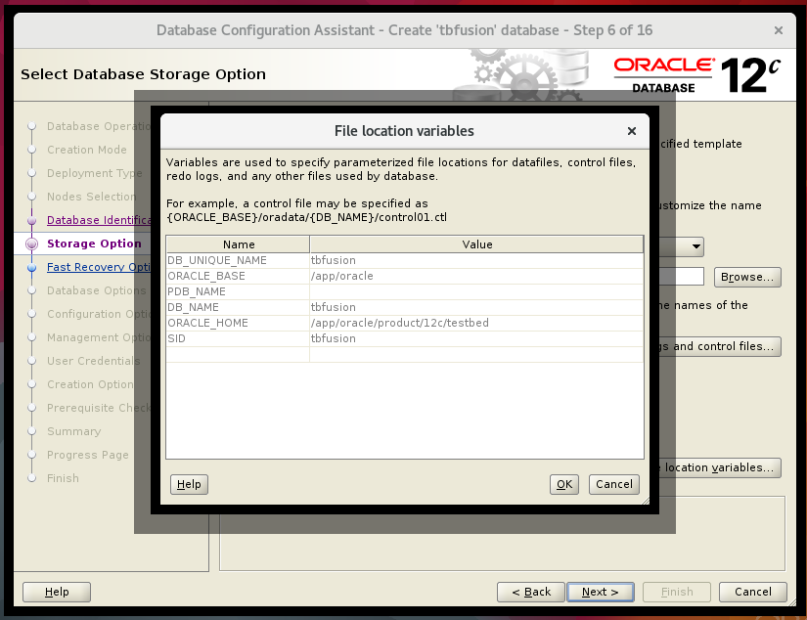

Click OK

Kết quả sau khi thực hiện

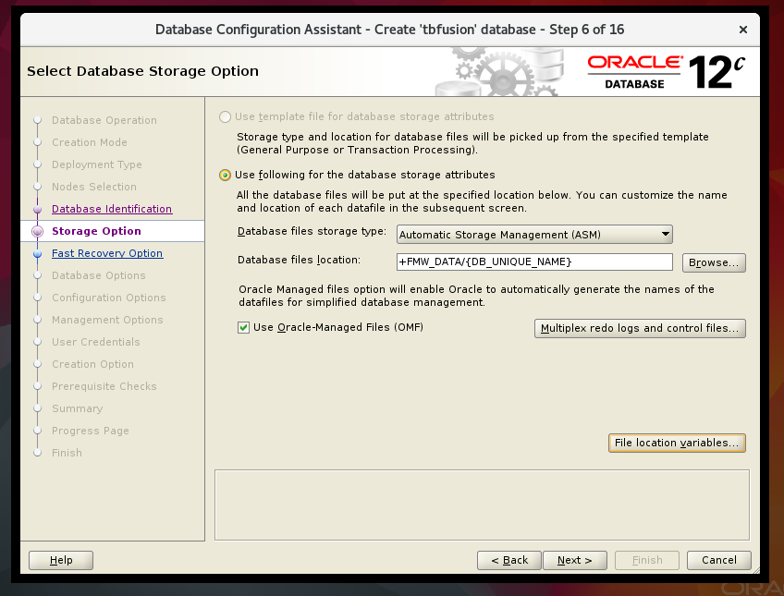

Click Next

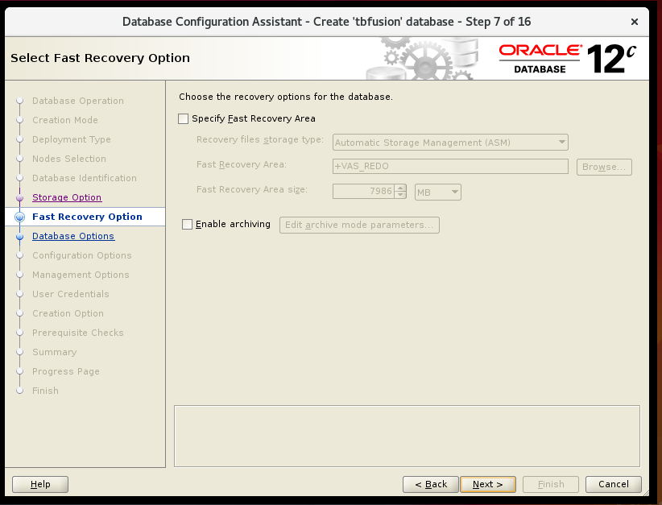

Click next

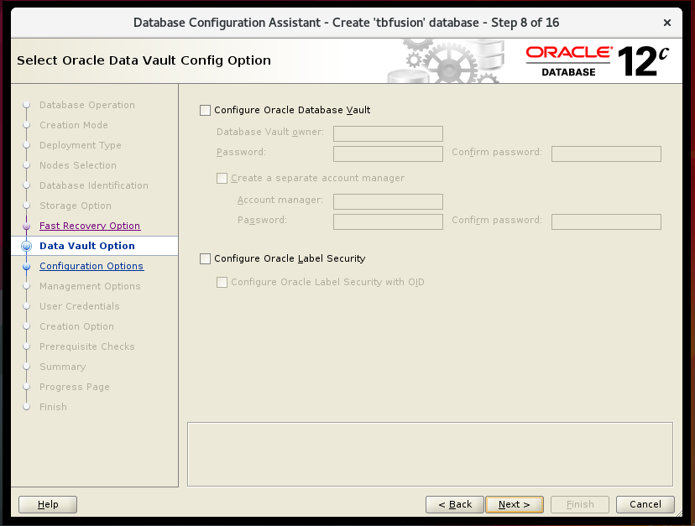

Click Next

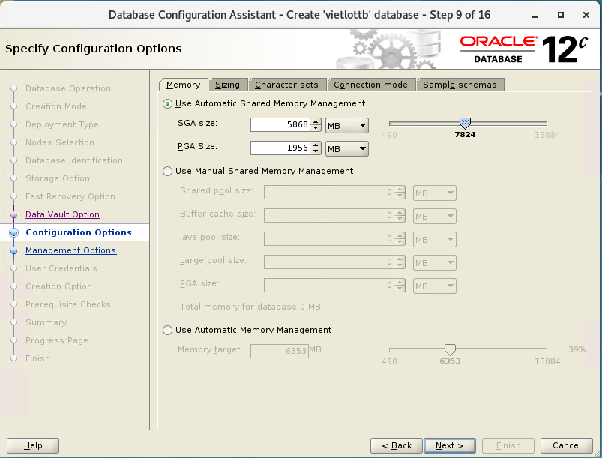

Click tab sizing

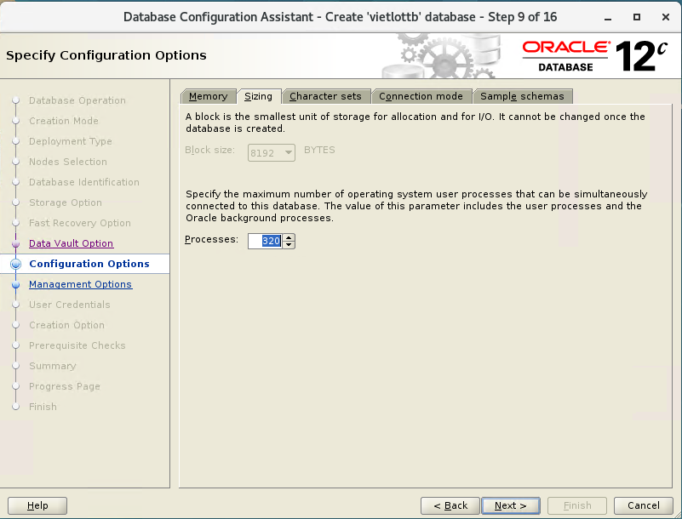

Click Character sets

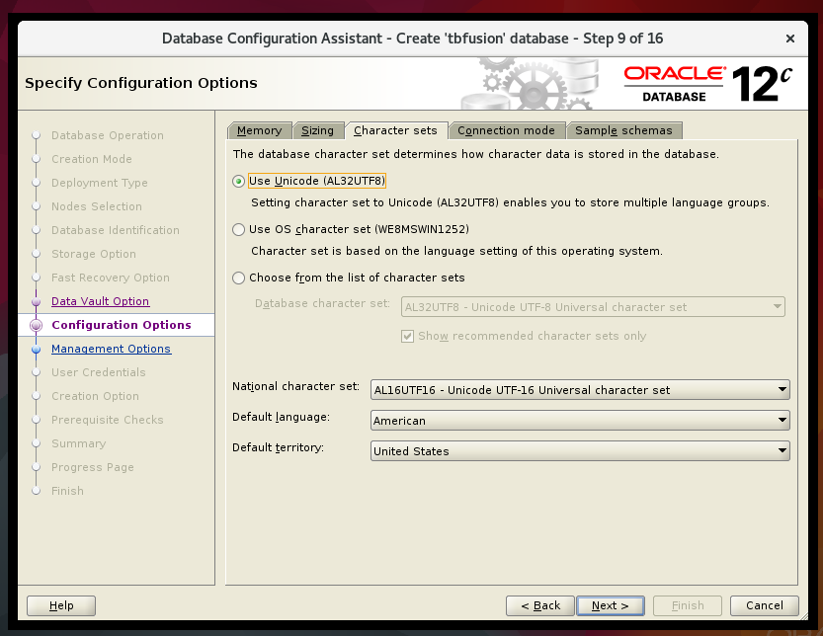

Click Connection mode

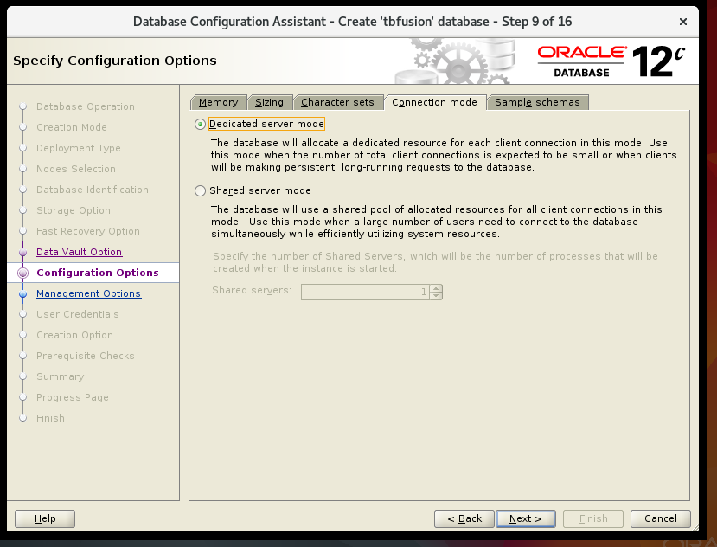

Click sample schemas

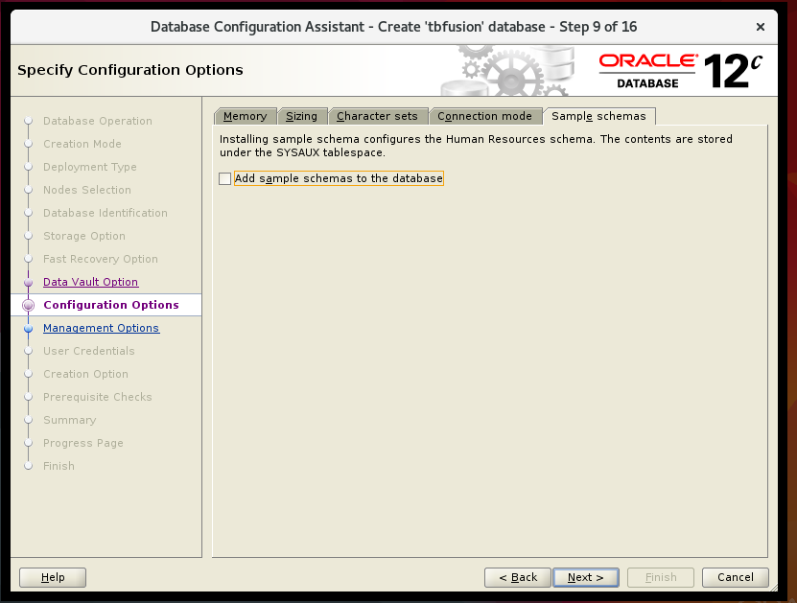

Click Next

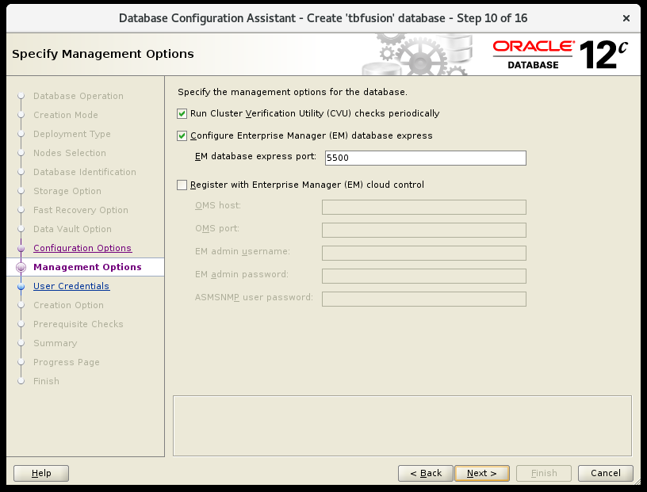

Click Next

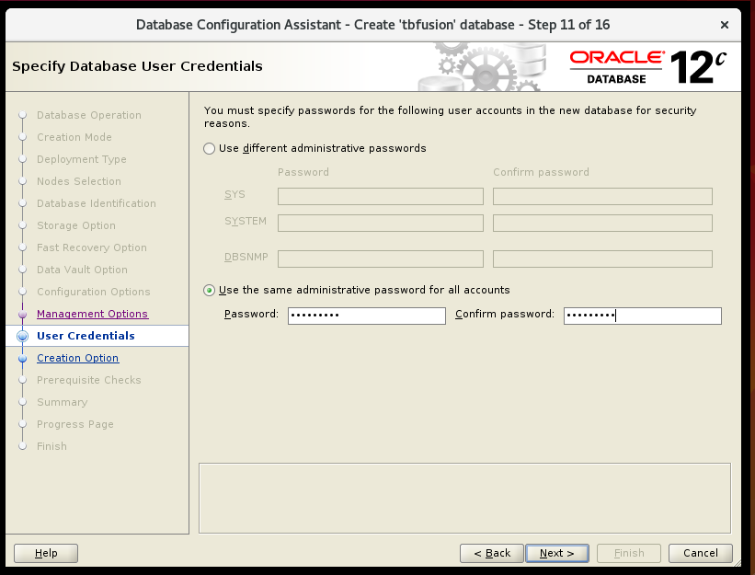

Password : **Admin#123**

Click Next

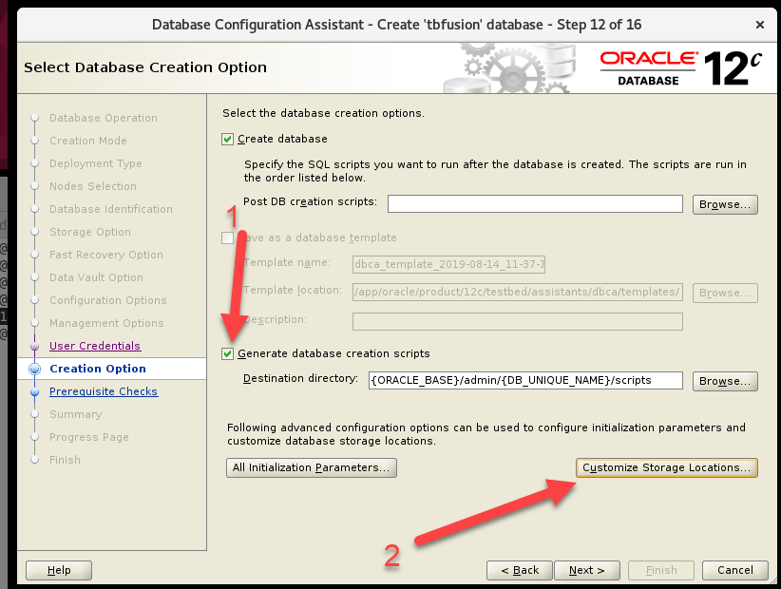

Click Customize Storage Location

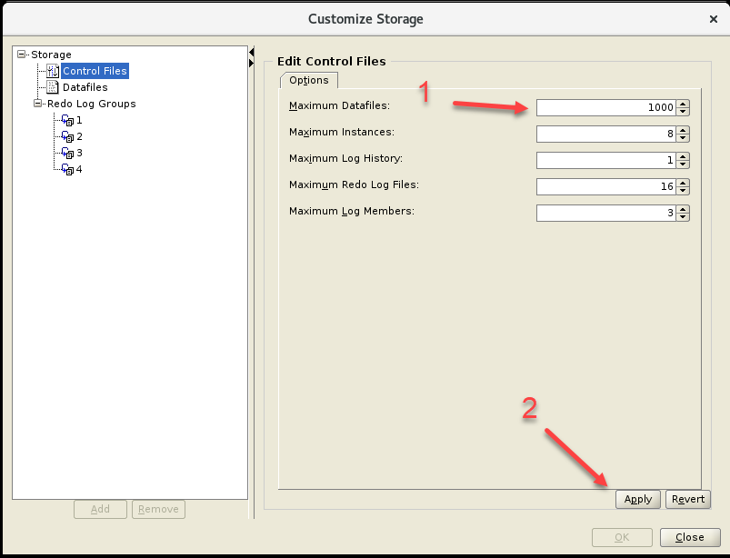

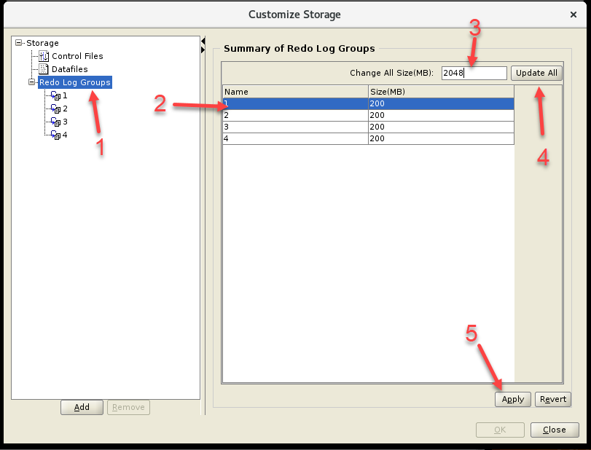

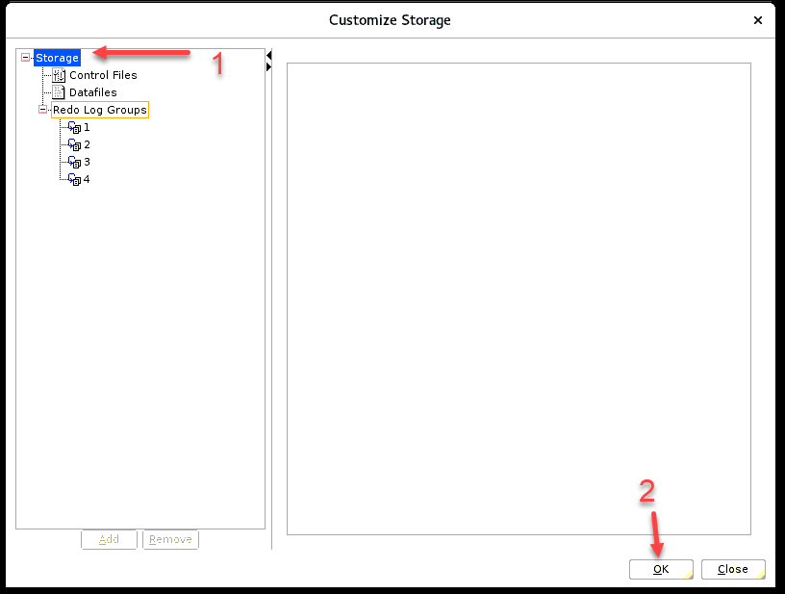

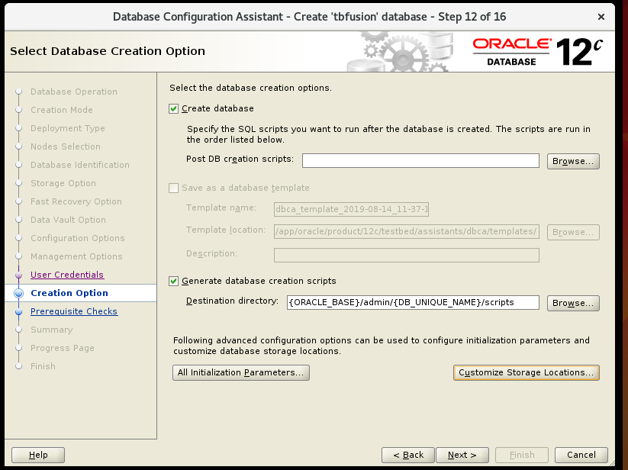

Click Next

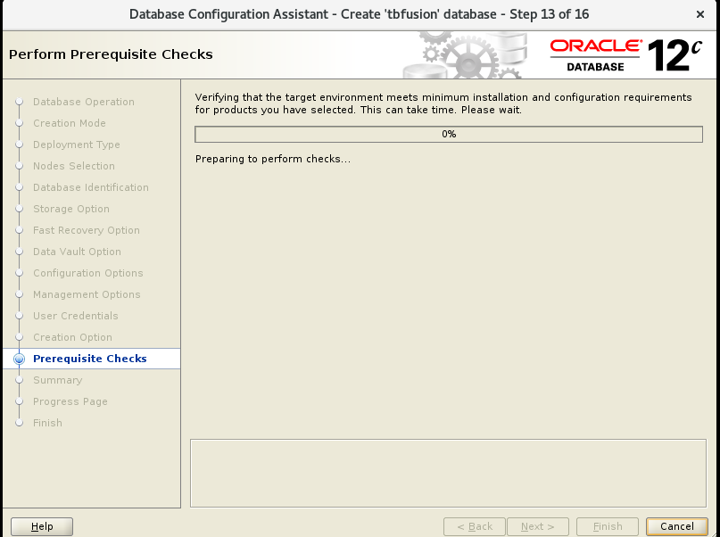

Waiting for DB is being created

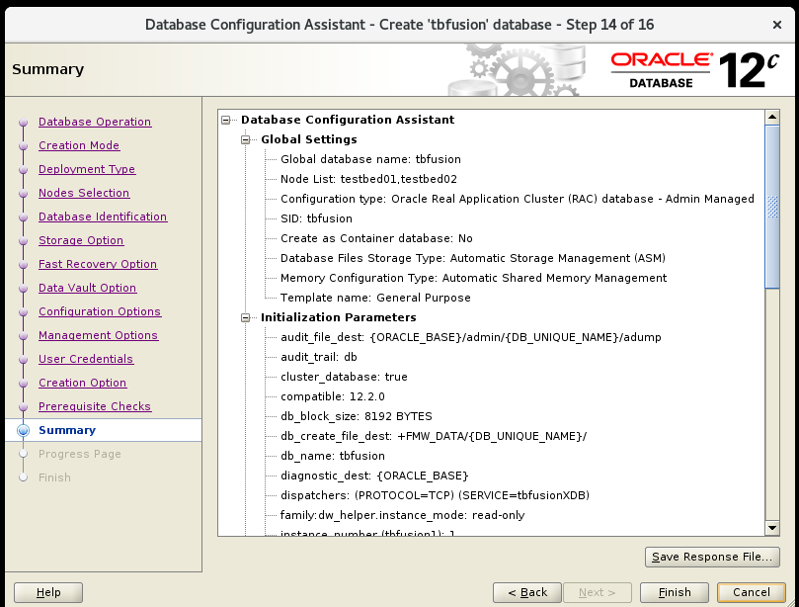

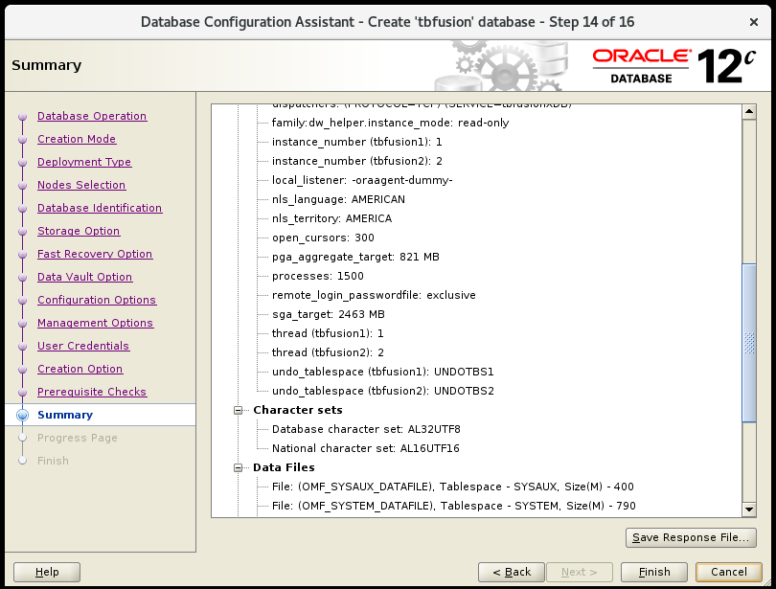

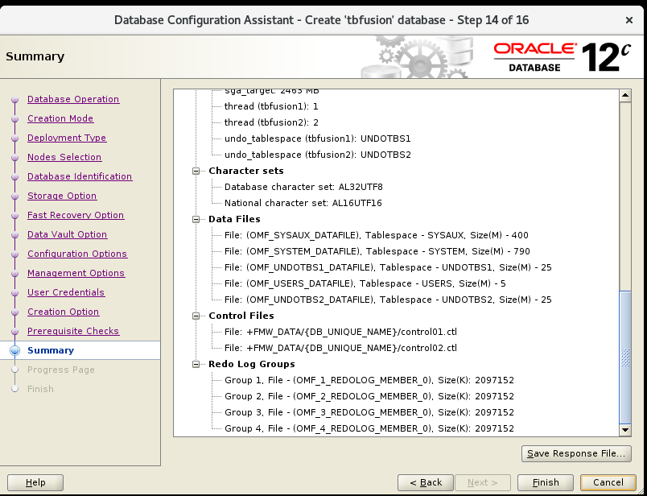

Click Finish

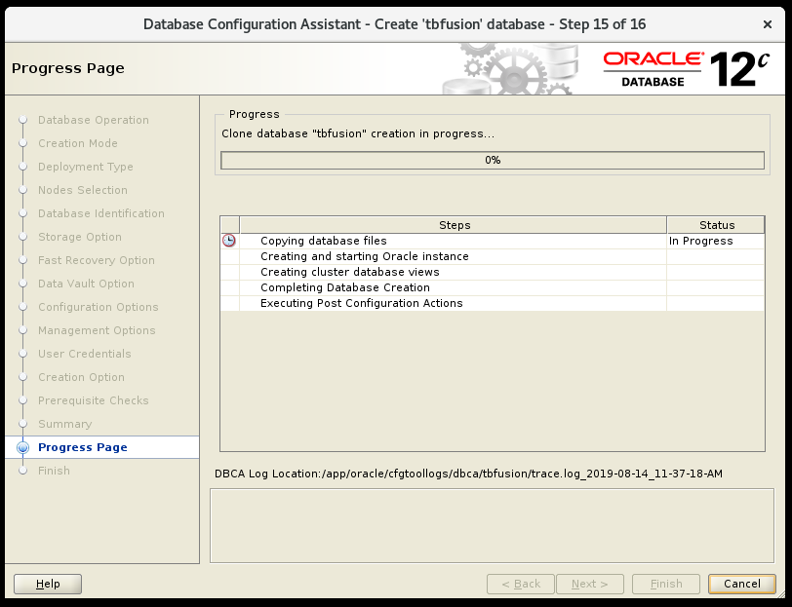

Waiting

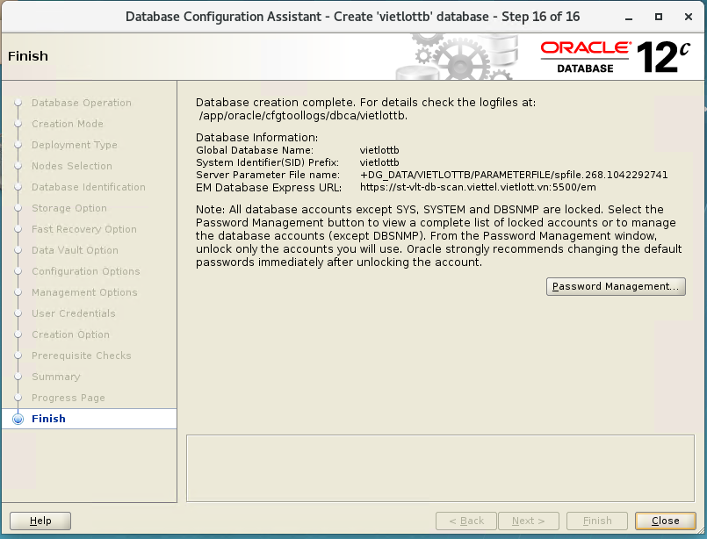

Click Close

Hoàn thành tạo Database

Kiểm tra

oracle@st-vlt-db1:~$ srvctl config

vietlottb

[oracle@st-vlt-db2 ~]$ srvctl config database -db vietlottb

Database unique name: vietlottb

Database name: vietlott

Oracle home: /app/oracle/product/12c/vietlott_db

Oracle user: oracle

Spfile: +DG_DATA/VIETLOTTB/PARAMETERFILE/spfile.268.1042292741

Password file: +DG_DATA/VIETLOTTB/PASSWORD/pwdvietlottb.256.1042292579

Domain:

Start options: open

Stop options: immediate

Database role: PRIMARY

Management policy: AUTOMATIC

Server pools:

Disk Groups: DG_DATA

Mount point paths:

Services:

Type: RAC

Start concurrency:

Stop concurrency:

OSDBA group: dba

OSOPER group: oper

Database instances: vietlottb1,vietlottb2

Configured nodes: st-vlt-db1,st-vlt-db2

CSS critical: no

CPU count: 0

Memory target: 0

Maximum memory: 0

Default network number for database services:

Database is administrator managed

[oracle@st-vlt-db1 bin]$ srvctl status database -db vietlottb -v

Instance vietlottb1 is running on node st-vlt-db1. Instance status: Open.

Instance vietlottb2 is running on node st-vlt-db2. Instance status: Open.

[oracle@st-vlt-db1 bin]$ sqlplus 'sys/Admin#123@vietlottb as sysdba'

SQL*Plus: Release 12.2.0.1.0 Production on Fri Jun 5 13:53:24 2020

Copyright (c) 1982, 2016, Oracle. All rights reserved.

Connected to:

Oracle Database 12c Enterprise Edition Release 12.2.0.1.0 - 64bit Production

SQL>

SQL> set wrap off

SQL> SELECT * FROM V$ACTIVE_INSTANCES;

rows will be truncated

INST_NUMBER INST_NAME

----------- --------------------------------------------------------------------

1 st-vlt-db1:vasdb1

2 testbed02:vasdb2

SQL>

* 1. Remove Database

Open dbca in vncviewer

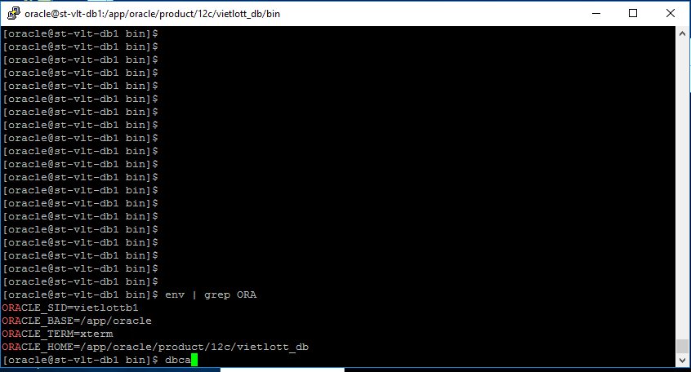

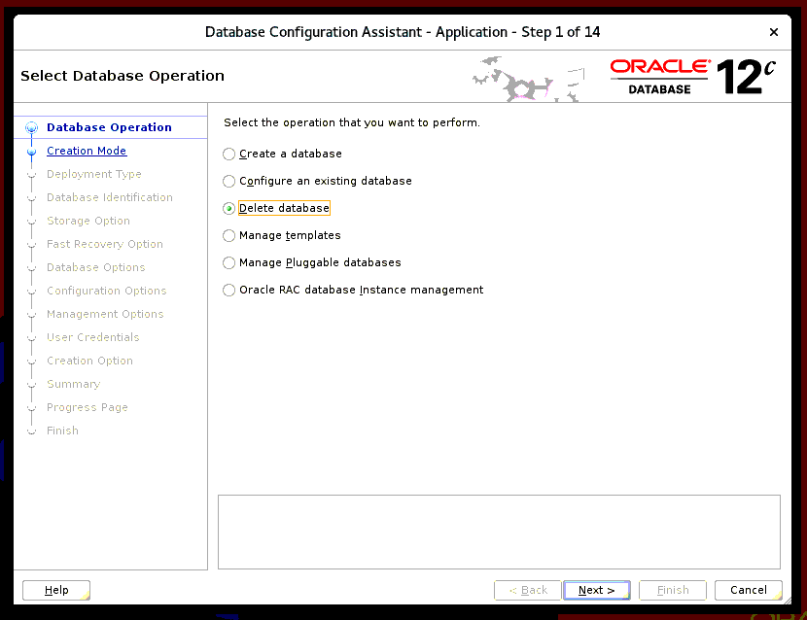

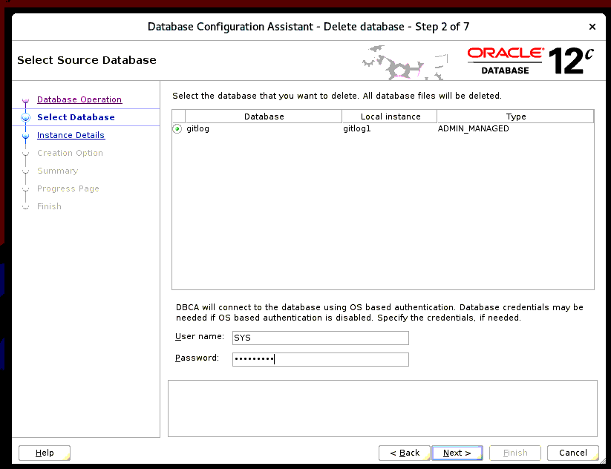

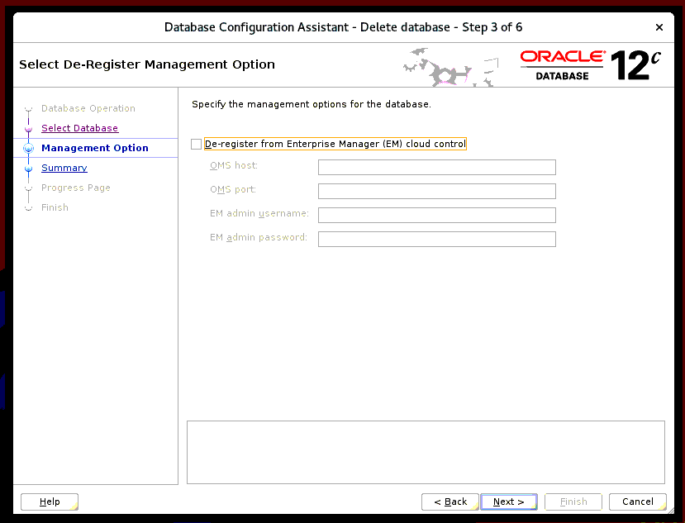

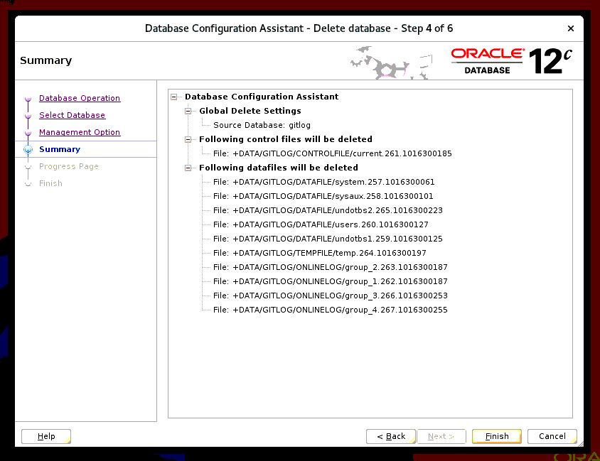

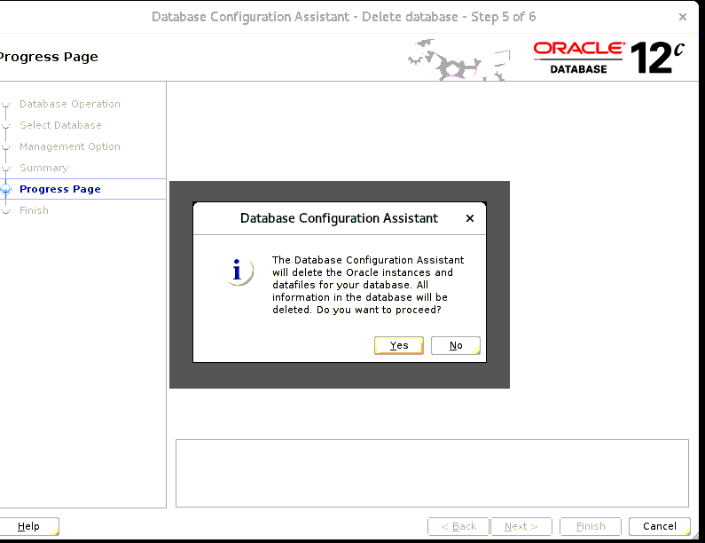

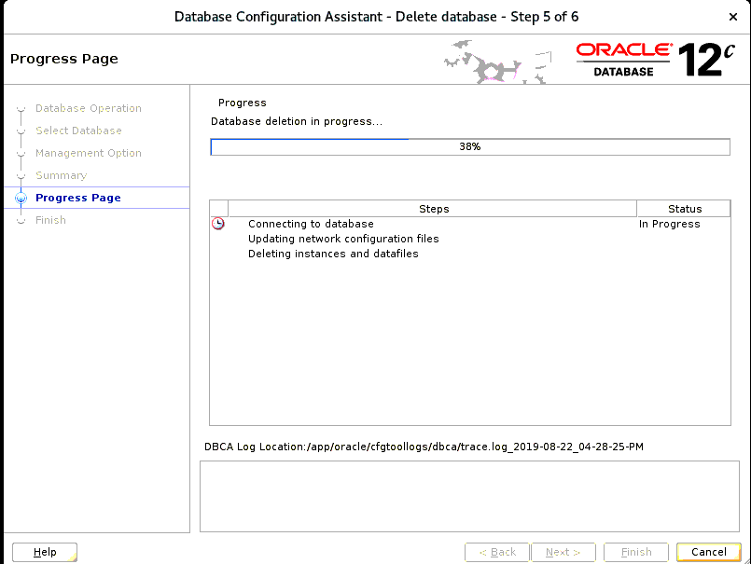

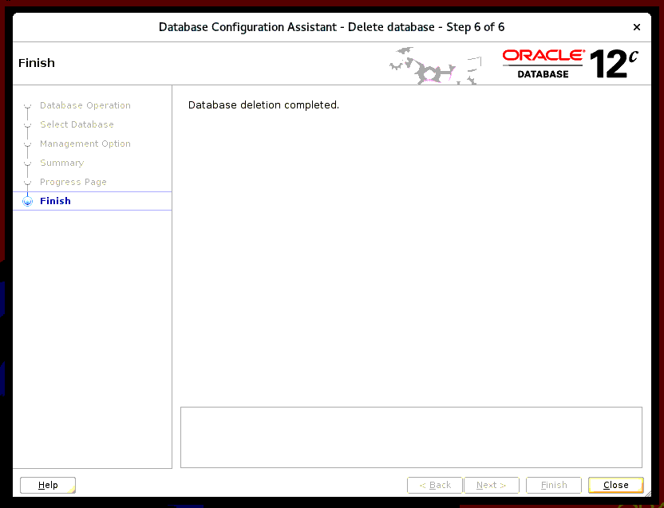

Deinstall Oracle Database

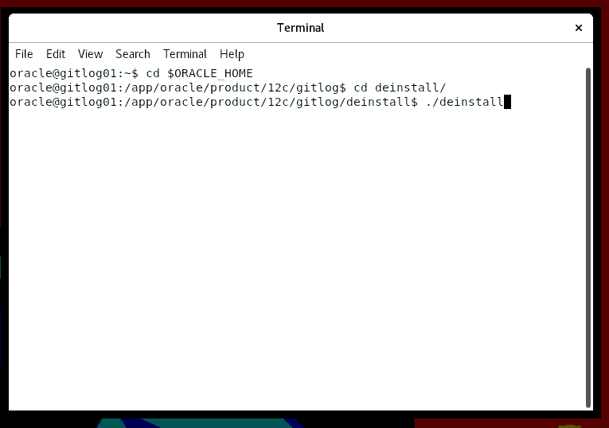

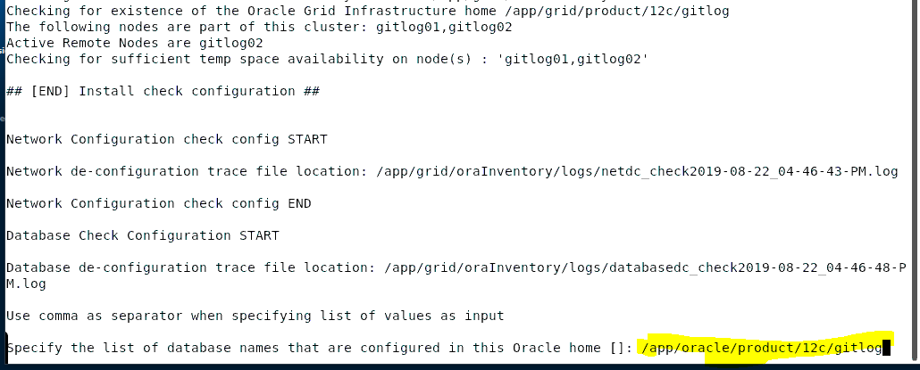



Reference

**Grid**

<https://www.oracle-scripts.net/useful-oracle-rac-commands/>

<https://www.youtube.com/watch?v=9z73NVG3J7Q&list=PL78Ui1VNtU1SvaMRcN_7H7dYV7STALfkh&index=1>

<https://www.oraclenext.com/2015/04/installing-oracle-12c-release-1-rac-on.html>

**Deconfig Grid**

<https://blog.toadworld.com/2017/08/08/deinstall-oracle-grid-infrastructure-12-2-failed-installation>

<https://docs.oracle.com/database/121/CWLIN/rem_orcl.htm#CWLIN346>

**Database**

<https://www.fatihacar.com/blog/oracle-12c-r2-12-2-0-1-rac-installation-steps-on-oracle-linux-7-3/>

**DBCA**

<https://gavinsoorma.com/2013/06/oracle12c-database-creation-using-dbca/>

<http://logic.edchen.org/how-to-build-18c-rac-4-of-4-creating-a-rac-database/>

**Grid Check ERROR**

<http://www.voidcn.com/article/p-zwkdhdic-rk.html>

<http://franck-mosse.blogspot.com/2013/12/how-to-recover-from-crs-0184-cannot.html>

Kill

<https://support.oracle.com/epmos/faces/DocumentDisplay?_afrLoop=138248354966885&parent=EXTERNAL_SEARCH&sourceId=PROBLEM&id=1392934.1&_afrWindowMode=0&_adf.ctrl-state=11vhx7id9v_53>

ERROR

1. INS-32123 gi install script failed

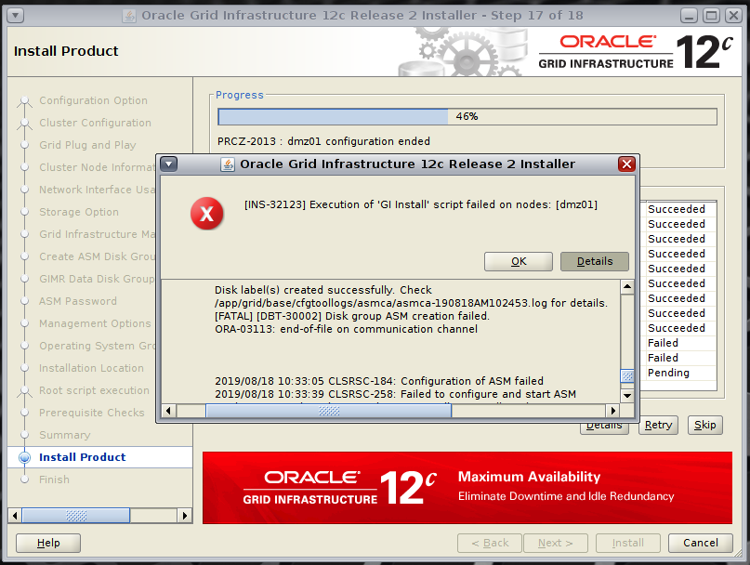

<https://www.xbdba.com/2019/04/11/ora-00845-memory_target-not-supported-on-this-system/>

**CRS-4000: Command Create failed, or completed with errors.**

**Failure initializing entries in /etc/oracle/scls_scr/node1**

grid@dmz01:/app/grid/product/12c/dmz$ cd $ORACLE_BASE

grid@dmz01:/app/grid/base$ find . | grep ckptGridHA

find: cannot read dir ./tfa/dmz01/diag/tfa: Permission denied

./crsdata/@global/crsconfig/ckptGridHA_global.xml

./crsdata/localhost/crsconfig/ckptGridHA_localhost.xml

grid@dmz01:/app/grid/base$ cd crsdata/localhost/crsconfig

grid@dmz01:/app/grid/base/crsdata/localhost/crsconfig$ ls

ckptGridHA_localhost.xml

grid@dmz01:/app/grid/base/crsdata/localhost/crsconfig$

grid@dmz01:/app/grid/base/crsdata/localhost/crsconfig$

grid@dmz01:/app/grid/base/crsdata/localhost/crsconfig$ mv ckptGridHA_localhost.xml ckptGridHA_localhost_bk.xml

grid@dmz01:/app/grid/base/crsdata/localhost/crsconfig$

<https://aprakash.wordpress.com/2011/08/26/crs-4046-invalid-oracle-clusterware-configuration-11gr2/>